City of Moreland

Hosken Reserve
Redevelopment Masterplan
Final Report

Produced by:

ASR Research Pty Ltd Leisure Planners
Mike Smith and Associates Landscape Architects
Hede Architects

March 2009

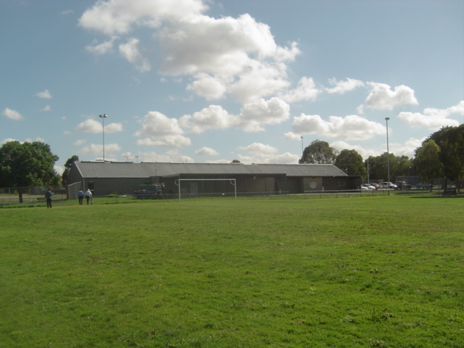

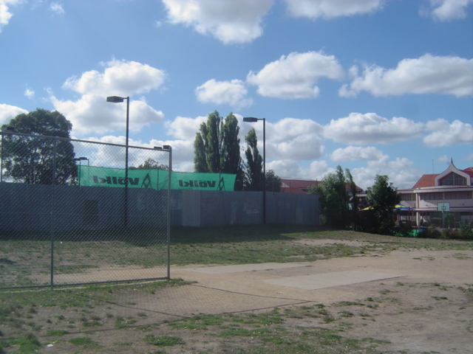
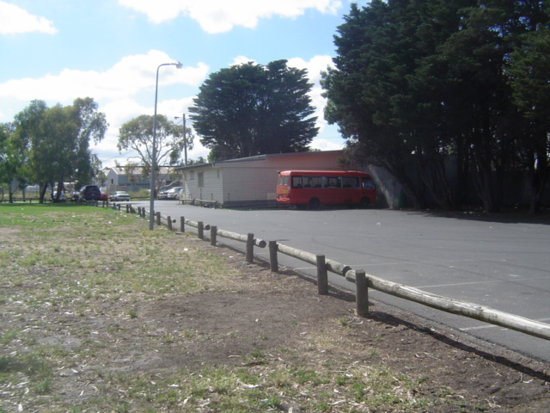
TABLE OF CONTENTS

SECTION ONE - INTRODUCTION 4
1.1 Purpose and Objectives of Study 4
1.2 Project Methodology 4
SECTION TWO – PROJECT DEFINITION MEETING 6
2.1 Introduction 6
2.2 Outcomes 6
SECTION THREE - LITERATURE REVIEW 8
3.1 Purpose of Review 8
3.2 Documents 8
3.3 Implications of Review for Masterplan 15
SECTION FOUR - THE RESERVE 17
4.1 Introduction 17
4.2 Open Space Context 17
4.3 Occupancy and Maintenance Arrangements 19
SECTION FIVE - EXISTING CONDITIONS/SITE ASSESSMENT 21
5.1 Introduction 21
5.2 Condition Assessment 21
5.3 Summary 25
SECTION SIX - LEISURE TRENDS/ DEMOGRAPHICS 27
6.1 Introduction 27
6.2 Leisure Trends 27
6.3 Demographics 29
6.4 Implications for Masterplan 30
SECTION SEVEN - CONSULTATION 31
7.1 Introduction 31
7.2 Council 31
7.3 User groups 37
7.4 Residents/Businesses/ Local Interest Groups 43
SECTION EIGHT – MASTERPLAN OPTIONS 46
8.1 Introduction 46
8.2 List of Improvements/Assessment of Merit 46
SECTION NINE - MASTERPLAN 57
9.1 Introduction 57
9.2 Masterplan Objectives 57
9.3 Timelines and Costs 58
9.4 Masterplan Options 59
9.5 Central Pavilion 59
9.6 Merits of each option/thoughts of Key Stakeholders 61
9.7 Key Issue: Cricket 62
9.8 Litter control/maintenance 62
9.9 Recommendations 63
APPENDICES 74

SECTION ONE - INTRODUCTION

1.1 Purpose and Objectives of Study

The purpose of the study was to produce a cohesive plan to guide the long term redevelopment of Hosken Reserve. The objectives of the study were to:

- Determine the future functions of the reserve
- Assess the condition of the reserve and its facilities from a landscape, functional, access, structural, environmental and safety perspective
- Identify the facility needs of existing and potential users groups and how these needs could be addressed
- Investigate opportunities to enhance the passive spaces at the reserve
- Prepare a masterplan for the reserve which contains a prioritised list of development works and estimates of the costs of these works.

1.2 Project Methodology

The methodology for the development of the masterplan was divided into eight related stages. A brief summary of the stages is as follows:

- Stage 1 - Project Definition Meeting - A meeting was held with the Council staff and Recreation Portfolio Councillors for the purpose of clarifying the objectives of the masterplanning process and discussing in detail any key/sensitive issues
- Stage 2 - Literature Review - Relevant Council files, strategy documents and operational policies were reviewed
- Stage 4 – Analysis of Leisure Trends/Demographic Projections – Relevant leisure and demographic trends were analysed and the implications of these characteristics for the future development of the reserve were identified
- Stage 5 - Audit of Existing Conditions/Use - The existing conditions at and use of the reserve were described. This description has the following components:
- A written assessment of the physical condition of the individual components of the reserve (Section 5.2)
- A plan which illustrates and describes the condition of the components of the reserve (See Plan A)
- Stage 6 - Consultation - User clubs, relevant Council officers, Councillors, other interested group and residents were consulted about their use of the reserve and the improvements that were needed
- Stage 7 – Draft Report - The findings of the previous research were documented in a draft report. Included in this report were a list of the works suggested by key stakeholders, an assessment of the merit of each works item, a set of recommended works and a preliminary masterplan. Council reviewed the report and suggested deletions and additions were noted. The draft report and preliminary masterplan were amended in response to the Council feedback.
- Stage 8 - Final Report – The draft report and masterplan were publicly exhibited and feedback received. The report and masterplan were amended in response to the feedback and was converted to a final report.

SECTION TWO – PROJECT DEFINITION MEETING

2.1 Introduction

This section summarises the outcomes of the project definition meeting between the consultant team, Moreland Leisure Services Staff and Recreation Portfolio Councillors. The purpose of the meeting was to discuss the background to the study and the key issues that need to be taken into consideration or addressed in the planning process.

2.2 Outcomes

The outcomes of the meeting were as follows:

- 1n 2003, a Planning Group was formed to produce a redevelopment plan for Hosken Reserve. The Group comprised representatives of Council, the local community and the five user organisations – King Khalid College, North Coburg Saints Football Club, Haig Amateur Cricket Club, Merlynston Tennis Club and Pascoe Vale Soccer Club
- The Group’s development vision for the reserve was that it be transformed into a ‘vibrant community recreation hub’ catering for cricket, football, soccer, informal play and general local community activities. However, the Group soon realised that the reserve did not have the capacity to satisfy the growing facility needs of the user groups – i.e. the soccer club wanted more playing fields but the oval where these fields could be provided was being used for football; the football club wanted a longer oval but there was no space for an extension; the Australian International Academy wanted access to the full reserve for play during recesses and interschool competitions but this would overload the playing fields etc
- The Northern Saints Football Club, the main proponent of the community hub vision, was presented with an opportunity to merge with another club and get access to a larger oval. It decided to take up this opportunity and recently relocated to Mutton Reserve in Fawkner. This leaves Hosken Reserve with no winter user of its cricket/football oval and little impetus for the continuation of the Hosken Reserve Planning Group
- The Pascoe Vale Soccer Club indicated that it was interested in using the cricket/football oval in the reserve for soccer training and games. This would require a reconfiguration of the oval into rectangular fields. However, this was problematic because of the central location of the turf wicket
- The Australian International Academy was concerned that its access to the reserve was being reduced at a time when its enrolments were growing. It asked Council to review its position and allow the school greater access
- In response to the above, Council determined to undertake a masterplanning process for the reserve which formally addressed the following issues:
- School access
- The need for more soccer fields
- The suitability of the pavilion
- Encouraging greater passive use of the reserve
- The adequacy of the carparks
- The condition and adequacy of the playgrounds, pathways, park furniture, lighting and vegetation.

SECTION THREE - LITERATURE REVIEW

3.1 Purpose of Review

This section presents the findings of the literature review. The purpose of the review was to ensure that the masterplan’s recommendations were consistent with and took into consideration the relevant recommendations, strategic directions and policy positions of previous Council planning processes.

3.2 Documents

The following documents/files were reviewed:

Moreland Council Plan 2005-2010

Moreland Open Space Strategy 2004

Moreland Municipal Public Health Plan 2003
- Moreland Leisure Plan 2001-2006
- Moreland Disability Policy and Action Plan 2003-2006
- Moreland Building Assets Management Strategy 2007
- Moreland Integrated Transport Strategy 2007
- Moreland Playground Strategy 2007- 2017
- Moreland Arts Strategy 2006- 2010
- Moreland Bike Plan 2000.

3.2.1 Moreland Council Plan

This plan outlines Council’s strategic objectives and priorities for the period 2005-2010. The objectives and priorities that have relevance to the redevelopment of Hosken Reserve are as follows:

Strategic Objectives:

- Improving social conditions
- Improving built and natural environment.

Priorities:

- Design and construct infrastructure with regard to the needs of people with a disability and environmental sustainability development requirements
- Ensure that asset planning is policy driven, meets the aspirations of residents, provides for access and equity, builds better asset usage and considers environmental impacts
- Improve the walking networks in Moreland, including improved footpaths, provision of shade and infrastructure such as dog refuse bins
- Improve the standard of playgrounds, particularly for children with a disability
- Ensure that all development within the municipality is environmentally sustainable
- Investigate sharing open space with local schools. Pursue opportunities through the State Government ‘Shared Facilities’ funding program
- Consider opportunities to increase the use of sporting facilities
- Improve sport and recreation opportunities for all young people and women of all ages
- Continue the upgrading of sporting infrastructure
- Review adequacy of bins in sporting parks, open spaces, walking tracks, retails areas and bus stops
- Improve the overall appearance of open space
- Install water saving equipment in parks and gardens; include computer controlled sprinkler systems and the use of plant species that require less water.

3.2.2 Moreland Open Space Strategy

The purpose of this strategy was to provide a long term strategic plan for the provision, development, management and use of open space areas in Moreland. The plan outlines the Council’s goal, priority strategic directions, planning principles and specific actions for open space provision. The sections of the strategy that have relevance for the Hosken Reserve Masterplan are as follows:

Goal:

- To develop and maintain a high quality, resource-efficient network of open spaces in Moreland that will satisfy current and projected community needs in a sustainable way.

Priority strategic directions:

- Diversify play environments and open space facilities to meet the needs of children and youth
- Design and develop parkland which is distinctive and expresses local landscape character in attractive, sustainable landscapes, well-designed structures and park furniture and art installations
- Restore ‘natural’ landscapes, mainly along waterways, to provide habitat for indigenous plants and animals and informal outdoor recreation.

Principles:

- Plant indigenous species in open space unless there is an established park landscape character, a particular functional need or specific design feature that requires another species
- Implement the principles of water sensitive urban design in open space development and redevelopment
- Utilise up-to-date sustainable environmental design and technology in open space development and redevelopment
- In park development and improvement works, provide access for people with a range of disabilities as much as possible
- Ensure the design and maintenance of open space provides a high standard of safety for users
- Ensure that any new buildings, other structures and car parks cause minimal encroachment into public open space or reduction in public access
- Maximise interaction and passive surveillance opportunities of open space
- Encourage walking by developing and/or enhancing pedestrian links and circuits between and through parks
- Commission public and/or community art projects as part of park development projects.

3.2.3 Health, Safety & Well-being in Moreland; Moreland Municipal Public Health Plan

The plan outlines the short and long term actions that Council will take to help improve the health and well-being of the Moreland community. The plan contains the following actions that have implications for the redevelopment of Hosken Reserve:

- Design and maintain quality infrastructure that is safe and promotes physical activity
- Ensure that the public environment promotes safety, physical activity and community strengthening
- Reduce risk factors for skin cancer by enhancing sun protection in public spaces
- Provide and maintain a range of recreation facilities and open space that promote health and well being.

3.2.4 Moreland Leisure Plan

This plan defines Council’s role in leisure provision and outlines a series of actions to enhance leisure opportunities and facilities in Moreland. The plan does not contain any direct references to Hosken Reserve but outlines the following key strategic directions/principles that have relevance to the future development of the reserve:

- Council will undertake an audit of existing turf tables to explore extension options to accommodate specific requests from cricket organisations before considering any new developments
- Council will increase shade structures/areas in playgrounds and ensure that play equipment complies with design standards
- Council will ensure that the future development of active parks will only be undertaken after a masterplan has been developed for the whole reserve to ensure that the sporting areas are surrounded by open space areas designed to provide a range of recreation, play and aesthetic principles
- Council will prepare guidelines for the development of social facilities on Council land which will ensure that residential amenity is protected while the usage of the facilities is optimised.

3.2.5 Moreland Disability Policy and Action Plan

This document outlines the Council’s key directions with respect to improving disability access and involving disabled people in community life. The period of the plan has expired but it contains the following objectives and actions that still have relevance to the Hosken Reserve masterplanning process:

Objectives

- Improve the physical environment so it is safe accessible and inclusive for all
- Improve access to services and facilities for people with a disability.

Actions

- Ensure all playgrounds are compliant with the Disability Discrimination Act and Australian Standards
- Conduct a disability audit of Council buildings every 4 years
- Upgrade public toilets to ensure they are disability accessible.

3.2.6 Moreland Building Assets Management Strategy

This document sets out a range of strategies and actions to improve Council’s buildings. The short term goal of the strategy is to establish systems and processes for the better management of building assets. The long term goal is to provide facilities which meet user and useability expectations and allow for equity of access. The key outcomes that the strategy will achieve are well maintained buildings which comply with legislation codes, are cost effective and are configured to achieve maximum utilisation.

3.2.7 Moreland Integrated Transport Strategy

This document provides a strategy for improving access and movement across the city in an economic and environmentally sustainable manner. A key objective of the strategy is to enhance Moreland’s walking network by making existing paths more accessible, linking the paths and connecting them to key destinations. The strategy does not contain specific recommendations about Hosken Reserve or the paths in North Coburg. However, it contains some comments about parks which have relevance to the redevelopment of Hosken Reserve. The Strategy says that “the design of parks and other public spaces needs to eliminate dark corners and other environments where harassment is likely’. It suggests that a pedestrian plan be developed which maps walking destinations including shops, schools, parks, public transports points etc. It recommends that all paths, including those through parks, be inspected to ensure they present no barrier to movement.

3.2.8 Moreland Playground Strategy

This document provides strategic directions with respect to the planning, design, location and maintenance of playgrounds in Moreland. The strategy does not contain specific recommendations about the playground in Hosken Reserve. Instead, it outlines a number of objectives and general recommendations which have implications for the playground. These objectives and recommendations are:

Objectives

- Increase the diversity of play experiences available from individual playgrounds
- Increase the diversity of play experiences in each suburb
- Increase the range of age groups that playgrounds cater for
- Improve the accessibility of play spaces for all users
- Improve pedestrian access to playgrounds
- Provide more play opportunities for children with disabilities
- Maintain Moreland’s playgrounds so that they comply with safety standards and are presented in a clean and attractive manner
- Address the impact that dogs have on playground safety and cleanliness
- Improve the provision of shade at playgrounds
- Provide fencing where there needs to be a barrier between the equipment and potential dangers
- Improve the safety and usage of existing playgrounds.

Actions

- Provide greater play opportunities for older children and teenagers
- Recognise the need for appropriate zoning of recreational activities around playgrounds opportunities e.g. proximity of half courts to playground equipment
- When equipment is upgraded in playgrounds, aim to achieve a balance between the four categories of play behaviour
- Vary play equipment, materials, the nature of the site works and landscape elements from park to park
- Offer equipment to suit a variety of age groups and abilities within each play setting
- Encourage diversity of play experiences by creating informal play spaces through the landscaping around playgrounds. The play value of rocks, leaves twigs and other natural elements should be promoted through landscape development surrounding play equipment
- Improve path networks at existing parks to enable safe access to play equipment and toilet facilities or other amenities
- Improve pedestrian access to playgrounds by providing pathways through reserves to link playgrounds into the residential neighbourhood
- Include the minimum disability access requirements in the redevelopment of playgrounds in district or significant local parks
- Continue to conduct frequent inspections and prompt repair of damaged equipment
- Continue to enforce local laws requiring dogs to be on lead within 15 metres of playgrounds
- Assess the existing natural shade at playgrounds and allocate funding for tree planting and construction of shade
- Assess the potential hazards (main roads and waterways) at each playground and consider fencing where needed
- Create safe crossing points on busy roads so children can safely access existing playgrounds.

3.2.9 Moreland Arts Strategy

This strategy provides directions for Council in continuing to promote, stimulate and support arts activities in the City. The strategy commits Council to providing public art in outdoor spaces.

3.2.10 Moreland Bike Plan

This plan outlines a series of steps aimed at implementing the cycling directions set out in Council’s Integrated Transport Strategy. The plan concentrates on the development of an ‘on and off road’ bicycle network and the provision of appropriate facilities for cyclists on the network. Hosken Reserve is not part of the formal network but is used as a route by cyclists riding to and from school, work and/or sports activities. Some of the support facilities as described in the Bike Plan – bike racks, water stations etc – should be considered for provision in Hosken Reserve.

3.3 Implications of Review for Masterplan

The strategies/plans contain principles, objectives, directions/actions that should be considered in the development of the Hosken Reserve Masterplan. These are:

- Improving disability access to buildings. Upgrading public toilets and pavilions to make them disability accessible
- Diversifying and improving the standard of playgrounds and ensuring compliance with DDA and Australian Standards. Improving access to playgrounds and providing appropriate fencing. Creating informal play spaces around playgrounds and making playgrounds safe from dogs
- Distinctively designing and developing reserves. Expressing the local landscape character in the design of parks. Providing attractive, well designed structures and park furniture. Ideally planting indigenous species
- Ensuring park and facility development observes ESD principles and promotes safety
- Ensuring minimal encroachment of open space by buildings and carparks
- Promoting physical activity through the design of parks
- Enhancing shade and shelter
- Surrounding playing fields with passive space that is attractive and provides for informal play
- Improving walking networks
- Ensuring buildings are well maintained, comply with legislation/codes, cost effective and configured to achieve maximum utilisation
- Considering public art installations
- Providing support facilities for bikes – racks, seats, water fountains etc.

SECTION FOUR - THE RESERVE

4.1 Introduction

The purpose of this section is to outline the open space context and the occupancy, maintenance and management arrangements at Hosken Reserve.

4.2 Open Space Context

4.2.1 Location, components and nearby reserves
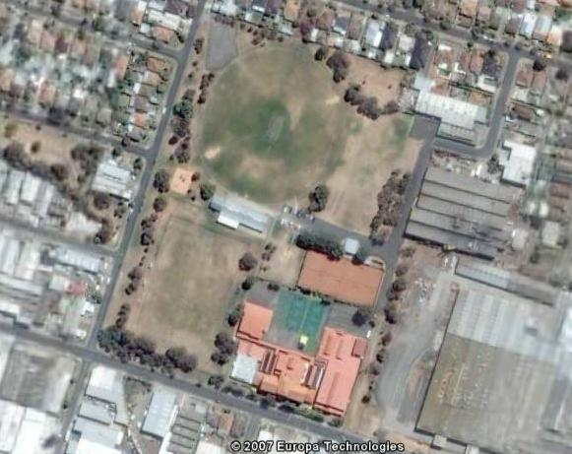
Hosken Reserve is a 5.5ha park located off Sheppard St in Coburg North (see Map 1). The Park is predominantly an active sporting reserve. It comprises a soccer field; football/cricket oval with a turf table; a rectangular field with concrete wicket; central soccer/cricket/football pavilion; tennis clubhouse; 3 carparking areas; playground and cricket practice nets. The reserve is bounded by Pallett St to the west, houses to the north, Sheppard St to the east and the Australian International Academy and Bakers Rd to the south. The reserve has houses along or adjacent to its western and northern edges and industrial areas to the west, south and east. The Academy is on 1.4ha of land which is very small for a secondary college – thus its reliance on the reserve as a play space and a venue for intra and inter-school sports. The main soccer field is fenced which restricts public access.

Map 1 – Hosken Reserve, Coburg North
Cricket Football Oval
Soccer Field
Australian International Academy
Tennis Club
Central Pavilion
Industrial areas
Industrial areas
Industrial areas
Residential areas
Residential areas
Playground

As a passive/informal space, the reserve mainly caters for the community bounded by Gaffney St, the railway line, Boundary Rd and Sussex St. As an active sporting space, the reserve has a larger catchment. Essentially the catchment area is determined by the standard of sport played at the reserve, the history and ‘pulling power’ of the clubs using the reserve, and the proximity of like reserves/clubs. For the purpose of this report, the catchment area for active sports is nominated as Coburg North and Pascoe Vale South.

5 other parcels of open space are located within 1.6kms of the Park. These include Charles Mutton Reserve (1), Parker Reserve and Merri Creek (2), Hallam Reserve (3), Rauburn Reserve (4) and Richards Reserve (5).

Table 1 – Nearby Reserves
Area | Reserve | Facilities | Function
1 | Charles Mutton Reserve | 2 Ovals (synthetic wickets)  3 Bowling greens  4 Tennis courts  Athletics track  3 Pavilions  Playground | Predominantly sporting reserve – tennis, football, cricket, lawn bowls, athletics
2 | Parker Reserve and Merri Creek | 2 Cricket/soccer fields (synthetic wickets)  Baseball Field  Pavilion  Playground | Predominantly sporting reserve – soccer, cricket, baseball
3 | Hallam Reserve | 1 Cricket/soccer field (turf wicket)  Pavilion  Playground | Predominantly sporting reserve – soccer, cricket, baseball
4 | Rauburn Reserve | 1 Cricket /football field (turf wicket)  Pavilion  Playground | Predominantly sporting reserve –cricket, football
5 | Richards Reserve | Cycling track  Soccer field inside track  Pavilion  Playground | Predominantly sporting reserve – cycling soccer training

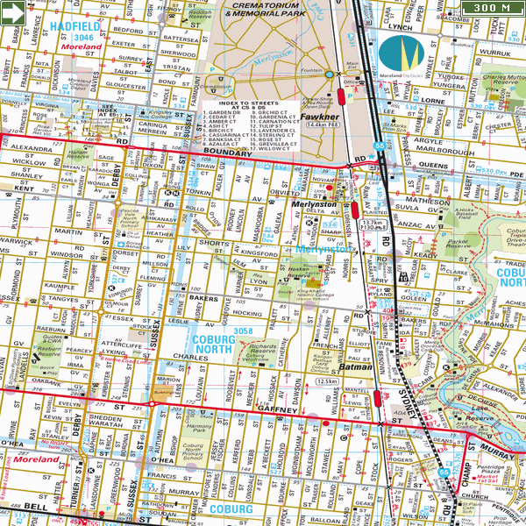
Map 2 – Location of nearby open space

The nearby reserves are used for the following purposes:
1

Table 2 – Nearby reserves
3

2

4
5

4.2.2 Proximity of like facilities

As indicated in section 4.2.1, the reserve accommodates a playground, soccer field, cricket/football oval and tennis facilities. The closest venues which contain one or more of these elements are as follows:

Table 2 – Proximity of like facilities
Venue | Location | Distance from Hosken Reserve
Soccer | Parker Reserve | 600m
Cricket | Parker Reserve | 600m
Tennis | Mutton Reserve | 1600m
Playground | Parker Reserve | 600m
Passive Park | Merri Creek | 700m

4.3 Occupancy and Maintenance Arrangements

Occupancy

The occupancy arrangements between Council and the clubs using Hosken Reserve are as follows:

Table 3 – Occupancy arrangements
Organisation | Arrangement | Start | Duration | Expires
Pascoe Vale Soccer Club – Pavilion and Playing Fields | Annual allocation | 1/1/2008 | 12 months | 31/12/2008
Haig Amateur Cricket Club – Pavilion and Paying Field | Seasonal allocation | 1/10/2007 | 6 months | 31/3/2008
Merlynston Tennis Club – Clubhouse and Tennis Courts | Lease | 1/3/2006 | 10 years | 29/2/2016
Australian International Academy | Individual approvals for competition use

Management and Maintenance

Management and maintenance arrangement at the reserve are as follows:

Table 4 – Management and maintenance responsibilities
Organisation/Unit | Tasks
MCC Leisure Services | Allocation of sports fields and pavilions  Monitoring compliance with seasonal allocation agreements  Inspection of facilities  Facilities planning and development ( inc. capital development submissions)
MCC Parks | Maintenance of sports fields and passive areas  Maintenance of trees  Maintenance of car parks and paths  Maintenance of park furniture and fencing
MCC Street Cleansing | Litter control
MCC Building maintenance | Maintenance of buildings  Maintenance of access roads and car parks  Maintenance of training lights
MCC Property Services | Management of leases
User Groups | Compliance with terms of their leases and seasonal agreements relating to maintenance

With respect to maintenance, in normal years Council will annually renovate, top-dress and oversow the fields. Council also restores the turf wicket table at the end of the winter season and prepares it for weekly competition. Council Park’s Unit believes that the maintenance regime is satisfactory for the current level of use of the reserve.

SECTION FIVE - EXISTING CONDITIONS/SITE ASSESSMENT

5.1 Introduction

This section describes the condition of the various component areas of and facilities at the reserve from a structural, landscape character/design and horticultural quality perspective. The assessment has been made from inspections of the component facilities by the consultant team, discussions with Council officers and reserve users and reference to condition reports prepared by Council.

5.2 Condition Assessment

Boundary Fencing

The boundary fencing consists of a number of fencing types these include:

- North boundary – A number of separate residential paling fences line this boundary. The fences are in fair to good condition. Three sheds/garages back onto the reserve. Two are of corrugated iron construction and one is constructed of brick. The paling fences and sheds/garages do not create an aesthetically pleasing backdrop
- South boundary – The tennis court is surrounded by a tall corrugated iron fence which forms a solid barrier and detracts from the appeal of the reserve. A more appropriate fence would allow visual permeability through to the tennis courts. The fence between the school and the soccer pitch is a 2.4 metre high chain wire fence and is in good condition
- East boundary – Two factories back onto the eastern edge of the reserve. The factories’ walls are constructed of corrugated iron and are rusting. There are also significant lengths of chain wire mesh fencing along this boundary. The fencing is in reasonable condition
- West boundary – Treated pine barrier rails line this boundary from the northwest corner to the soccer pitch. The barrier rails appear worn and dated and many are damaged. The soccer pitch is surrounded by a 2.4 metre high chain wire mesh fence which is in good condition.

Entrances
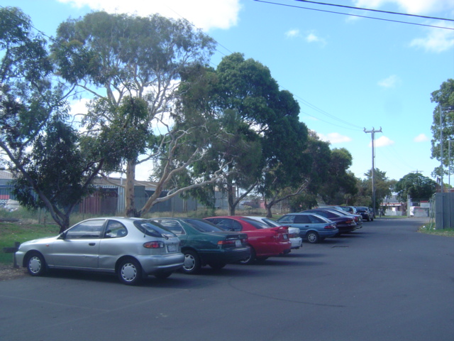
The main vehicular entrance to the reserve is in the northeast corner from Sheppard Street. An asphalt road provides access to parking and the reserve’s sports fields, courts and pavilions/club rooms. The main entrance is poorly defined. The other vehicular entrance is in the northwest corner from Pallett Street. This entrance is to an asphalt car parking area and does not provide access to the reserve’s central facilities. This parking area is mainly used on game days. These entrances are poorly signed on the main roads.

There is a lack of defined pedestrian entry points into the reserve; however two points of entry are to the northwest on Pallett Street and through the pedestrian access laneway from Shorts Road.

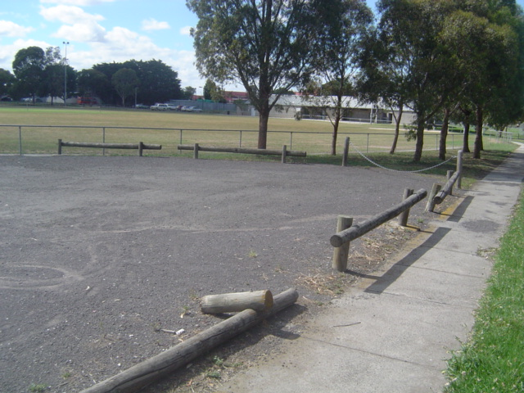
Car parks and access roads

Car parking is currently available in two areas of the reserve. These are:

- Car parking spaces along the main entrance access road and in the reserve, at the end of the access road and near the tennis courts and pavilions
- Car parking area in the northwest corner of the reserve. This area has no defined car parking spaces.

Playground

The playground is located midway along the western boundary of the reserve, 25 metres west of the cricket/soccer pavilion. The playground equipment is in good condition. The playground is small and limited in its capacity to cope with large numbers of children. There is no seating provided and the surrounding scattered eucalypts provide only dappled shade.

Sports fields and courts

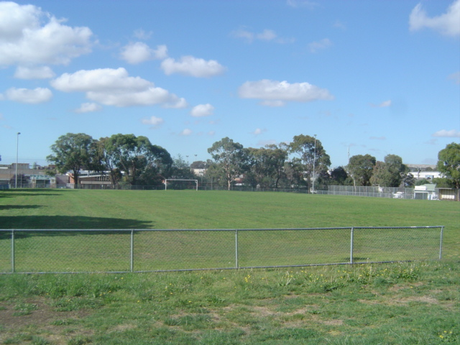
The reserve has one cricket/football oval as well as a senior sized soccer pitch. There is also a rectangular kick-about area with a concrete cricket pitch in the centre to the east of the oval. The oval is fenced with steel tube fencing with parking to the northwest and southeast of the oval being quite close to the perimeter. The oval has a turf wicket and is approximately 120 metres wide and 130 metres long. The oval is small for senior football but suitable in size for senior cricket.

There are four tennis courts which appear to be well maintained and in good condition. The tennis courts have night lighting (note the condition and effectiveness of the lighting was not assessed). The tennis courts are surrounded by a tall corrugated iron fence which is not aesthetically pleasing and does not allow visual permeability.

Grass cover/surface
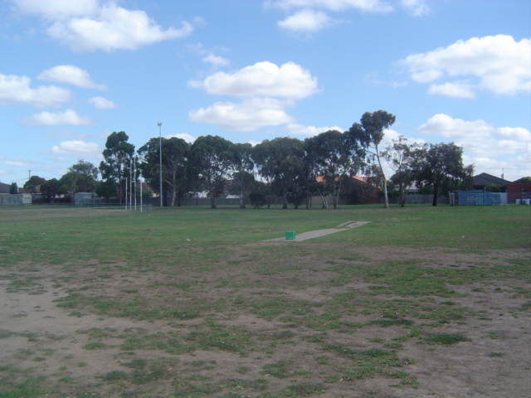
The grass cover on the oval was in average condition at the times of inspection (mid December 2007 and late February 2008). There were bare patches and other areas with scattered tufts of grass. These can pose a safety risk for cricketers.

The soccer pitch south of the pavilion has recently been sown with couch (a warm season grass). In some areas, the existing winter grass was not properly eradicated and is causing difficulties in the establishment of the couch. However, overall the surface is very good.

Training lights and towers

Tall light towers provide floodlights to the oval and soccer pitch. The towers appear to be structurally sound; however the condition or output of light of the floodlights was not assessed.

Vegetation

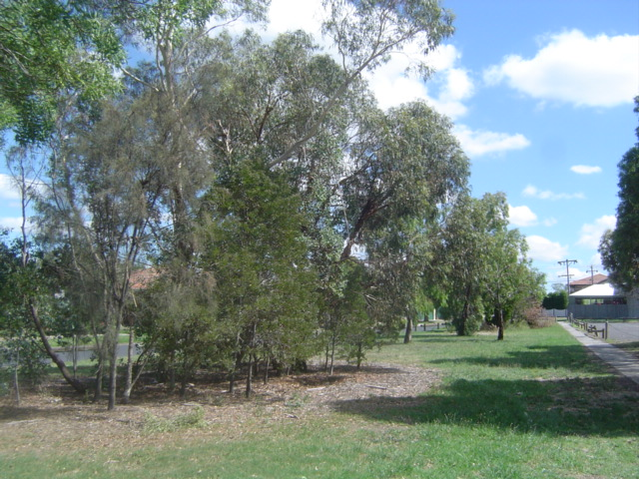
The vegetation within the park comprises of predominately native species with very few scattered exotic species. Of the tree species observed, Eucalyptus melliodora, Eucalyptus camaldulensis and Eucalyptus leucoxylon are indigenous to the area. Whilst the vegetation in the reserve is generally in good condition, there are some trees that are in poor condition.

Signage and security lighting

Lighting in the reserve is restricted to the parking areas and sports fields with the exception of one light provided in the open grassed area to the northeast of the reserve. Lighting is deficient in other areas of the reserve, including the pedestrian path.

Park furniture

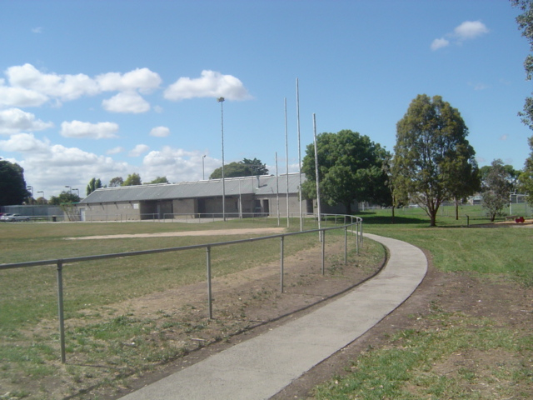
The existing seats in the reserve appear worn and dated and are in need of replacement. Two bins stands are present, one to the playground and another to the southeast of the oval; however no bins were attached at the time of assessment. Another bin is located in the parking area to the northwest corner. There is a lack of seating throughout the reserve, especially near the playground and in the spectator areas. No picnic facilities are provided.

Pathways

A concrete pathway extends from the carpark on the north-western edge of the reserve to the gate on the north-western corner of the school. The path is cracked and worn in parts particularly near the pavilion. There are no other paths in the reserve.

Built facilities
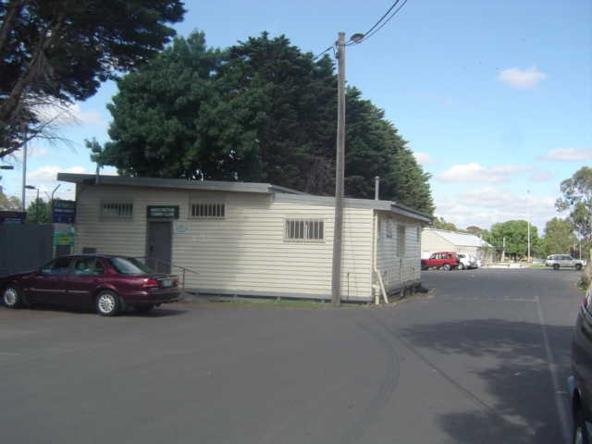
The built facilities in the reserve comprise a cricket/soccer pavilion, tennis pavilion and coaches’ boxes. There is also a weather station to the west of the cricket/soccer pavilion. The pavilions are not visually attractive but are in good structural condition. They are dated internally and need refurbishment.

5.3 Summary

The condition assessment indicated that the reserve has the following deficiencies which should be addressed in the masterplan:

- The entrances are poorly signed
- Boundary fencing is in reasonable condition but some areas are unattractive and block views
- The playground, although in good condition, is small and limited in capacity. It lacks seating and only has dappled shade
- The oval is in poor condition due to water restrictions. The turf table is in good condition
- The small rectangular field is in poor condition and concrete wicket has collapsed. The surface is badly worn
- The vegetation is predominately native species with some scattered exotic species. Some trees are indigenous to area. Most of the trees in the reserve are in good condition, some are in poor condition
- Lighting is restricted to the parking areas and playing fields and one light in the open grassed area to the northeast of the Reserve
- Seats appear worn and dated and in need of replacement. There is insufficient seating throughout the Reserve, especially near the playground and in spectator areas
- Pavilions are in good structural condition but need updating to meet current/future needs of users
- The tennis courts are in reasonable condition due to the availability of tank water. There are signs though that their condition is starting to decline
- The corrugated iron fence around the tennis courts is unsightly and should be removed.
- The carparking area in the north west of the reserve is poorly defined.
- There is only a small section of path in the reserve.

Plan A – Existing Conditions Plan
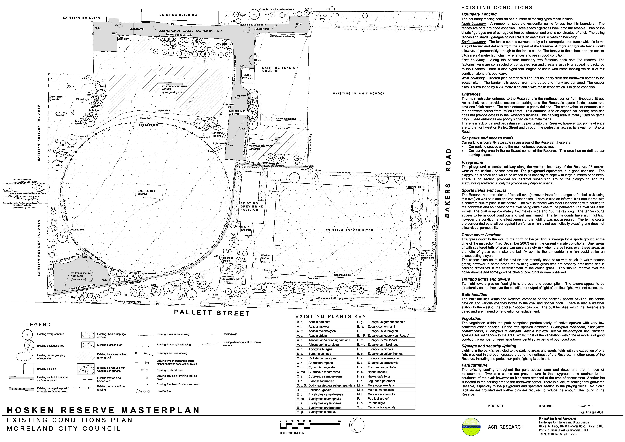

SECTION SIX - LEISURE TRENDS/ DEMOGRAPHICS

6.1 Introduction

The purpose of this section was to analyse relevant leisure and demographic trends and discuss their implications for the future use of Hosken Reserve.

6.2 Leisure Trends

There are a number of general leisure trends which should be taken into consideration in the masterplan. These are as follows:

General Leisure Trends - Informal recreation

- More people are choosing to recreate in informal and unstructured ways. As a consequence, activities such as recreational cycling, jogging and walking in parks for exercise and pleasure are becoming more prevalent
- The rate of pet ownership, particularly as companion animals for older adults, is increasing. Exercising dogs in parks has become a popular activity
- The popularity of activities that families can participate in together such as social tennis, picnicking and similar outdoor activities continues to grow
- Generally, adults are remaining fitter and more active until later in life. This is leading to an increased participation in veteran's sports and more frequent use of open space areas for walking, relaxation and social activities.

General Participation Trends - Active sport (confined to sports played at Hosken Reserve)

Soccer

- Football Federation Victoria (FFV) manages the major senior and junior soccer competitions in Melbourne. The number of players registered to play in the competitions run by FFV has increased by 13% over the past 3 years. The largest proportional increases have occurred in junior girls (+76%)
- Player numbers have increased in all regions of Melbourne. The largest rises have occurred in the south/south-eastern suburbs particularly in juniors
- Changes have recently been made to competition structures which will encourage the fielding of more senior men’s teams. Previously, a club could field a maximum of 3 teams in senior men’s competition. With the introduction of the men’s third grade competition, clubs can now field as many teams as they want.

AFL

- Participation in Australian football across Victoria is increasing, particularly in junior levels. 539 new teams have been established since 2001 (385 since 2005). The majority of new teams are from the City – 395 compared to 144 from the country
- Of the 322 new teams that formed in Melbourne since 2003, only 13 are senior teams
- Moreland’s participation rate in football is lower than the average for inner metropolitan Councils – 8% of males aged 5-39 compared to 10% for the inner metro area. Its rate is particularly low in the 5-12 age group – 22% compared to 31%.

Cricket

- There has been a steep increase in participation in Melbourne both junior and senior cricket over the past 3 years – a 22% jump in junior teams and 10% in seniors. All areas of Melbourne have risen, the largest increase occurring in the southern metro region (15%)
- Player numbers in the senior competition operating across Moreland – the Moreland/Moonee Valley Cricket Association - are steady. Numbers in local junior competitions are moderately increasing, particularly in lower age juniors.

Tennis

- The numbers of tennis associations and clubs in Melbourne have increased over the past ten years. Registered member numbers, however, have decreased
- Even though overall member numbers have declined, participation rates in tennis have risen in recent years. In 2006, 25% of the sport playing population throughout Australia participated in tennis, irrespective of the season. This was up 4% on 2000. Of the total population, over 10% played tennis, up from 6% in 1996. This suggests that the number of people playing social tennis has increased significantly.
- Weekday night tennis has grown in popularity whilst weekend senior tennis has significantly declined.

6.3 Demographics

The catchment areas served by the reserve for passive activities is the area bounded by Gaffney St, the railway line, Boundary Rd and Sussex St and for active sport activities is the suburbs of Coburg North and Pascoe Vale. Table 7 provides population projections for the combined Coburg North and Pascoe Vale area. An analysis of the projections indicates the following:

- The total population will increase by 1682 or 8% between 2007 and 2021
- The 0-9, 30-39, 70-79 and 80+ cohorts will decrease. The largest decrease will occur in the 30-39 age cohort (-314 people)
- The other age cohorts will increase, in particular the 40-59, 50-59 and 60-79 age cohorts which will rise by 17%, 42%, and 43% respectively
- The sub junior age cohorts (5-9 years) will decline by around 41 people, the junior age cohort (10-19) years will increase by 176 people and the senior age cohort (20-39 years) will decline by around 306 people. If participation rates in the active sports played at the reserve remain the same, these figures suggest that the demand for sub-junior sports will stay constant and senior sport will decline. The increasing middle age population will increase demand for passive spaces and for veterans’ sports like masters’ soccer.

Table 5 – Population Projections (Coburg North, Pascoe Vale combined)
 | Forecast years
Age cohorts | 2007 | 2013 | 2021 | +- | %+-
0 to 9 | 2558 | 2584 | 2492 | -66 | -3%
10 to 19 | 2263 | 2335 | 2439 | 176 | 8%
20 to 29 | 2743 | 2721 | 2751 | 8 | 0%
30 to 39 | 3537 | 3394 | 3223 | -314 | -9%
40 to 49 | 2956 | 3235 | 3447 | 491 | 17%
50 to 59 | 2183 | 2538 | 3089 | 906 | 42%
60 to 69 | 1627 | 1811 | 2333 | 706 | 43%
70 to 79 | 1752 | 1530 | 1627 | -125 | -7%
80+ | 1521 | 1577 | 1421 | -100 | -7%
Total | 21140 | 21725 | 22822 | 1682 | 8%

6.4 Implications for Masterplan

The implications of these leisure trends and demographics for the masterplan are as follows:

- The ageing of the local community and the growing popularity of activities such as walking for exercise and strolling will place increased demand on the passive areas of Hosken Reserve. This will heighten the need for improvements to the passive areas, such as the construction of pathways, installation of park furniture and provision of shade and shelter
- The participation trends for the sports played at the reserve (cricket and soccer) suggest that overall demand for the facilities will increase and use by juniors and women will rise significantly. These trends in demand need to be considered when developing the masterplan and making decisions about the size and design of pavilions, the size and number of playing fields and the priority of works.

SECTION SEVEN - CONSULTATION

7.1 Introduction

This section provides the outcomes of the consultation with the key stakeholders including Councillors and Council staff, user clubs, neighbouring school, local residents, nearby industry and local sports associations.

7.2 Council

7.2.1 Recreation Unit

Officers from Council’s Recreation Unit were asked to indicate what they consider to be the role of the reserve, its current deficiencies and the improvements needed. Their comments were as follows:

- Hosken Reserve is an important open space area with a diversity of roles. It:
- Is situated in a suburb, North Coburg, where there is a general lack of passive open space
- Provides for district level community sport, school sport, school play and informal play
- Provides for passive recreation where people can walk, ride, contemplate, spectate and picnic/eat lunch (i.e. people working in the industrial/commercial areas to the east of the reserve)
- Is used as a thoroughfare for people walking to and from school
- Connects the residential area west of the reserve with the industrial/commercial areas to the east
- Provides a drop off and pick up point for students attending the adjacent Australian International Academy
- Provides a visual and noise buffer to the industrial areas to the east
- The condition of the facilities at the reserve varies. The soccer field has recently been renovated and summer grass introduced. The grass cover is thick in most areas. The central pavilion is dated and requires upgrade. The surface of the cricket/football oval is rough and the grass cover is dying off. The playground is well maintained but may require new elements. The passive spaces need enhancement and the cricket nets are poorly located (facing the school)
- Council has deferred any decision on undertaking major works at the reserve pending the development of the masterplan. The soccer and tennis clubs recently received State Government grants of $30000 each to improve their facilities. The tennis club intends to spend the grant on resurfacing the courts. The soccer clubs will use the funds to sealing the spectator area at the front of the soccer pavilion
- No formal discussions have been held with the Australian International Academy about their contribution to the future development of the reserve. It may be reasonable for the school to contribute to works at the reserve that provide improved facilities for the students
- Some developments/projects are occurring in Coburg that have relevance to Hosken Reserve Masterplan. These include the development of a regional access all abilities playground in Harmony Park in Gaffney Street which will serve the North Coburg area and the construction of a Bunnings/Homemaker Centre, also in Gaffney Street. Developer contributions derived from the Homemaker Centre could potentially be used to improve Hosken Reserve
- There are no overlays or other formal planning constraints to the development of the reserve. However, it should be noted that permits will be required for the erection of any structures at the reserve such as lights and pavilions
- Council allocates $1.8m annually for the redevelopment of a sports pavilion and $0.5m annually for sports ground reconstruction. Whilst there is no notional budget allocation for the development of Hosken Reserve, these allocations could provide a funding source (in addition to other identified funding partnerships). The improvement of Hosken Reserve is thought to be a priority
- Council is willing to consider partnerships with a range of stakeholders, including private schools and clubs. Council has been involved in joint development partnerships – e.g. Box Forest College arts facility and Brunswick Secondary College hockey facility. Any further partnerships would be considered
- With the football club leaving, the reserve lends itself to development as a multi-field soccer venue. Council wants to support the growth and development of the Pascoe Vale Soccer Club due to its focus on junior participation. Hosken Reserve has the potential to effectively cater for this growth through appropriate redevelopment. The provision of a senior size synthetic field and/or small junior synthetic fields is worth considering as an effective means of providing facilities which will maximise use. A partnership with the school may be appropriate for a development of a synthetic surface field
- The development of the reserve as a multi-field soccer venue could be constrained by the turf wicket table in the middle of the oval. The fields may have to be located either side of the table which could make them narrow. This would not be an issue if the cricket club was relocated to another reserve. There are other venues available but they do not have turf wickets. Options for relocating the cricket club (if the club is willing) should be investigated.

7.2.2 Building Maintenance

Council’s Building Maintenance Officer was asked to comment on the condition of the built facilities in the reserve and indicate what improvements/changes he thought were necessary. His comments were as follows:

- The tennis and soccer pavilions are in good structural condition (some restumping of the tennis pavilion is needed). However, internally the pavilions are tired and need refurbishment
- Consideration should be given to replacing the tennis and central pavilion with a central integrated facility which provides for all the user clubs. This facility could offer both shared and dedicated spaces for the clubs
- The benefits of a consolidated, central facility are that the building would be optimally used and space would be freed up in the reserve for other purposes.

7.2.3 Open Space/Landscape design

Council’s Co-ordinator of Open Space Management, Design and Development was asked to give her thoughts on improvements that should be made at reserve. Her suggestions were as follows:

- Generally make the reserve more welcoming to informal users. Define spaces for passive recreation and enhance these spaces with landscaping and park furniture
- Provide more vegetation
- Investigate scope to expand and diversify the play facility
- Give consideration to providing BBQ and picnic facilities in the reserve
- Enhance view lines through the reserve
- Establish a path network in the reserve (possibly a circuit path).

7.2.4 Streets and Park Development

Council’s Parks Officer - Streets/Park Development was asked for his impression of the reserve and to suggest improvements. His comments were as follows:

- The reserve work wells as an active sporting reserve. It is not, however, used to its potential as a passive space
- This lack of passive use is mainly due to the passive elements of the reserve being undeveloped or in poor condition. The masterplan should recommend that the passive spaces be enhanced as a matter of priority. Works should include the following:
  - The upgrade and extension of the path network (note: it should remain concrete)
  - Provision of more shade, particularly in the main spectator areas, along the pathway, near the playground and over park furniture
  - Provision of additional park furniture (seats and tables) that is suitable for walkers, spectators and school students
  - If not required for active use, conversion of the rectangular playing field to the east of the main oval to a passive space. Creation of a picnic area at the northern end for use as a lunch space by the factory workers
  - Shading or painting of the factory walls to the east of the reserve
    - The playing fields are in reasonable condition considering the drought and water restrictions. The soccer field was recently line-rowed with summer grass. The grass seems to be spreading well. Similar work should be considered for the main oval.

7.2.5 Street Cleansing/Litter Management

Council’s Works Officer – Streets Cleansing was asked about waste management and litter control in the park; the improvements needed to these processes (if any) and his general thoughts about the condition of the reserve. His comments were as follows:
- The user clubs are provided with a number of litter bins. The clubs are required to distribute and retrieve these bins around the reserve on game days, place out for collection on garbage day and store away at other times. The system works well and no changes are recommended to the process
- The cricket and football clubs currently store their bins inside the front entrance to the pavilion. This is not a good location. An external cage should be provided when the pavilion is redeveloped
- Permanent bins are located near the playground and carparks. These bins are managed by Council. Further bins could be supplied if the masterplan recommends that more areas be provided in the reserve where people can regularly gather e.g. a picnic area near the factories
- There is a problem with windblown rubbish in the reserve around the main carpark. The rubbish is deposited by park users, in particular people using the carpark, and gets caught on the tennis fence and under the trees. It looks unsightly. Council often picks up the rubbish but it quickly returns. An education/enforcement program is required. It is also important that the masterplan does not recommend any structures or vegetation which will act as litter traps
- The improvements that should be made to the reserve are as follows:
  - Consideration should be given to converting the oval to summer grass
  - The passive spaces should be enhanced
  - Consideration should be given to installing a circuit path
  - The pavilion is dated and needs refurbishment.

7.2.6 Traffic Planning

Council’s Traffic Planner was asked to advise:

- Whether there were any traffic related works proposed for roads around the reserve?
- Whether there were problems relating to traffic in and around the reserve?
- Whether he would be concerned about any increase in activity in the reserve that could result in higher traffic volumes?
- His thoughts about the improvements that should occur at the reserve.

His comments were as follows:

- There are no traffic related works occurring around the reserve that would have implications for the redevelopment masterplan
- Council has not received any complaints from residents living near the reserve about traffic matters relating to the use of the reserve
- The streets around the reserve are reasonably quiet on Saturdays and Sundays but are much busier on weekdays when the factories in the area are operating. Pallett Street, which runs along the western boundary of the reserve, and Shorts Road to the north of the reserve are particularly busy streets. At the moment, the reserve gets most of its use on the weekends in winter and consequently traffic problems are minimal. However, traffic issues may arise if this pattern and level of use was to change - particularly if use during workings hours was to increase and the types of use generated cars. The main concern would be more cars parking in Pallett Street, causing congestion in a narrow road which gets a reasonable level of use by small to medium size trucks. A solution to this, if required, could be the provision of indented parking along the reserve side of Pallet Street
- The vehicle access points to the ground work well from a traffic perspective. The entrance off Sheppard Street appears to have the capacity to adequately cater for the vehicles, including buses, which access the reserve for school or recreational purposes. This should be retained as the main access point. The secondary access point off Pallett Street is not heavily used. It should be retained as it allows direct access to the reserve and provides the opportunity for people to park and spectate on the boundary line of the main playing field
- There is a concern about the safety of buses turning in the carpark near the schools. The provision of a turning circle should be considered.
- Recommended improvements to the reserve are upgrading the pathways, enhancing the passive spaces and addressing the bus turning issue.

7.2.7 Town Planning

Council’s Town Planner was asked whether there would be any concerns from a town planning perspective, if the masterplan for the reserve recommended or resulted in the following:

- The erection of more powerful training lights over the playing fields
- A substantial redevelopment or replacement of the pavilion
- Increases in the number of spectators watching sport at the reserve, the amount of traffic around the reserve and the numbers of cars parking in residential streets.

The Planner advised that the reserve was zoned ‘public park and recreation’ and that the erection of more powerful training lights and the replacement, refurbishment and/or extension of the pavilion at the reserve would require town planning approval. The major considerations would be whether the works were in character with the reserve and surrounding areas and whether the lights and pavilion would adversely impact on residential amenity.

The Planner stated that there may be concerns, from a neighbourhood amenity point of view, if there was a substantial increase in spectator numbers. The main concerns would be noise and traffic. However, he indicated that the concerns may not be strong at this reserve as it is flanked on two of its boundaries and part of its third boundary by a school and industrial areas.

7.3 User groups

Officials from the user groups were asked to provide information about the following (where relevant):

- The history of their group
- Participant/student numbers and trends
- The activities that the group uses the reserve for
- The groups future aims
- Predictions about future participant/group numbers
- The group’s facility needs
- The viability of the groups
- How could facilities at the reserve be improved (not just the group’s facilities).
- Any other matters they wanted to raise.

7.3.1 Pascoe Vale Soccer Club

- The Club formed in 1966 and played a number of venues around Coburg before settling at Hosken Reserve in 1992
- The club is strong socially and administratively and reasonably strong financially. In the past, it has been able to contribute funds and in-kind labour towards the development of facilities in Hosken Reserve
- In 2007, the Club fielded 9 teams - 2 senior men’s, 3 junior girls and 4 junior boys (note the Club had no junior teams in 2005). The Club anticipates that it will have 12 teams in 2008 and facilities permitting, will continue to grow strongly in future years. Its main aims with respect to club development are to expand its junior program, particularly the number of girls’ teams; establish some women teams and look at fielding a veterans’ team. The Club predicts that it could have as many as 25 teams within 5-10 years
- The Club’s senior men’s team plays in State League Division 2 – the third highest level of soccer in Melbourne. The Club is very competitive in this grade and aspires to be promoted to Division 1
- Currently, the Club undertakes its training activities and plays many of its home games at Hosken Reserve. It advises that the pavilion and playing field were able to cater for the Club’s needs when there were only a small number of teams and there were no water restrictions. The facilities are now finding it difficult to cope with the load
- The club’s facility needs/wants are as follows:
- Conversion of the main playing field to synthetic and the provision of at least one additional grass field. If synthetic is not feasible, the provision of 2 additional grass fields – 1 senior size and 1 junior size
- Competition quality floodlighting over the main playing field. Training quality floodlighting over the secondary fields
- Redeveloped main field and pavilion which meets the FFV’s specifications for a Class B venue
- Reconfigured and additional carparking
- Better lighting of the carpark and the areas around the pavilion
- Retention of the fence around the main field
- Redeveloped pavilion which provides social areas and 6 change areas and is designed so that it is suitable for both female and male players
- Externally accessible toilets
- Undercover spectator areas off the pavilion
- The Club suggested that the following improvements be made to passive areas of the reserve:
- More trees and park furniture
- Improved pathways
- Enhanced lighting.

7.3.2 Northern Saints Football Club (formerly North Coburg Saints Football Club)

- North Coburg Saints Football Club (formally St Oliver’s) formed in 1947. It amalgamated with Fawkner Park Football Club in 2007 to form the Northern Saints Football Club. The merged club will play its first season in 2008 and has relocated from Hosken Reserve to Mutton Reserve in Fawkner
- The merged Club will field 2 senior and 6 junior teams in 2008. It will compete in the Essendon District League with its senior team playing in B section. It hopes to grow in future years with more junior teams, a women’s team and a super-rules team
- North Coburg Saint’s reasons for merging with Fawkner Park and relocating to Mutton Reserve are as follows:
- Fawkner Park Football Club was folding, leaving the Fawkner area without a football club
- Fawkner’s demographics are more favourable than Coburg’s i.e. a younger population
- There are a number of clubs in Coburg competing for players whereas there would have been no club in Fawkner with Fawkner Park folding
- The facilities at Mutton Reserve are much better than those at Hosken Reserve: 2 senior fields, large pavilion and good lights and carparking at Mutton compared to 1 medium size field, rundown pavilion and poor lights and carparking at Hosken
- A potential opportunity to join with the cricket, bowls and tennis clubs at Mutton Reserve to form a Sports Club
- The Club’s suggested improvements to Hosken Reserve are as follows (even though it will not be playing there):
- Convert the oval to a soccer field/s in a manner that is suitable to the cricket club
- Upgrade the pavilion to provide better change and social facilities
- Make the reserve more visually attractive
- Give consideration to providing bocce facilities
  - The Club also requested that Council provide assistance with the enhancement of the facilities at Mutton Reserve.

7.3.3 Haig Amateur Cricket Club

- The Club commenced operation in the 1930s. It has 3 senior teams, 2 junior teams and a ‘have a go’ program. The junior program began in 2001
- The Club competes in the Moreland and Moonee Valley Cricket Association with its 1st X1 team in the top grade. The Clubs expects that it will field the same number of teams over the next decade
- The Club is happy with the condition of the oval and turf wicket at Hosken Reserve. It would like the pavilion to be upgraded – bigger changerooms and social area, a glass viewing area, better storage area for rubbish bins and veranda off the pavilion. It would also like the nets to be shifted to the rectangular field immediately north of the main carpark
- The Club is aware that the soccer club wants more playing fields and is happy for field/s to be developed on the oval as long as they do not compromise the Cricket Club’s use of the reserve
- The Cricket Club is also willing to consider being relocated to another reserve as long as the facilities and access arrangements are suitable.

7.3.4 Merlynston Tennis Club

- The Club is about 100 years old and has been located at Hosken Reserve for about 70 years
- The Club has a relatively stable membership of around 100 members. At its peak, the Club had 120 members and at its lowest about 80. The age breakdown is 60% seniors and 40% juniors
- The Club fields teams in the weekend junior and senior, weekday women’s and weeknight mixed competitions. It also has a coaching program. The Club is financially viable, has a strong committee and is confident about its future
- The positive aspects of the Club’s facilities and location at Hosken Reserve are as follows:
- The Club is located within a prominent active reserve
- The Club has a good relationship with the neighbouring school and the other user clubs
- The Club has 4 courts which is sufficient for its member numbers
- The court surfaces are en-tout-cas. This is the member’s preferred playing surface
- 2 of the courts are in good condition and 2 are in reasonable condition
- The Club has installed a water tank and therefore can water all courts
- The pavilion is large enough for the Club’s activities
- The fence around the courts provide a good wind barrier and helps to prevent the en-tout-cas from blowing off the court
- The courts are located away from houses and consequently there are no issues with neighbourhood amenity
- The concerns/issues about the Club’s facilities and Hosken Reserve are as follows:
- The Club is hidden away and visiting teams/players find it difficult to locate
- Although the preferred playing surface, the en-tout-cas courts are not easy to maintain, especially when restrictions on water use are imposed
- The clubhouse requires an internal upgrade and restumping in areas
- The fence around the courts is unattractive and traps litter. Litter is also a problem in other parts of the reserve
- The main carpark at the reserve is not big enough during busy periods e.g. on Saturdays when tennis, soccer and football are being played concurrently
- The carpark and areas around the buildings in the reserve are not well lit
- The trees lining the carpark and tennis fence are unattractive
- The reserve is visually unappealing
- The club’s priorities with respect to the redevelopment of its facilities and the reserve generally are as follows:
  - Resurfacing the en-tout-cas courts
  - Refurbishing the tennis clubhouse
  - Extending the carpark
  - Providing directional signage off Shorts Road to the reserve and tennis club
  - Improving litter control and pruning or removing the pine trees
  - Generally making the reserve more attractive.

7.3.5 Australian International Academy (formerly King Khalid College)

The secondary campus of the Academy is located next to the reserve. The campus currently has 650 students and is expected to grow to 900 - 1000 at full development (this may occur within the next 5 years).

The campus site has a land area of 1.4ha. This is small for a secondary college, especially a school that will have around 900 students at full development. Consequently, the site is nearly built out with school buildings and there is little outdoor play area and no playing fields. Therefore, the Academy relies heavily on Hosken Reserve for these spaces.

Until water restrictions were imposed, the Academy had access to all of the reserve for play during school recess times, physical education classes, intra-school activities like athletics training and inter-school activities such as football matches against other schools. In recent years, the Academy’s access to the grassed areas at the reserve has been limited to the cricket net area and the rectangular space to the north of the cricket nets. This is due Council’s concerns about overloading the playing fields in times of water restrictions.

The carpark at the reserve is important to the school. It is used by buses and individual parents for student ‘drop offs and pick ups’. The Academy also hires the tennis courts for physical education classes.

With respect to facility needs and the future development of the reserve, the Academy advised as follows:

- The Academy would like to get access to all the reserve for recess play
- It would prefer that the oval be retained so that when water restrictions are lifted it could use the reserve for football, cricket and soccer. However, it understands that there may be a community need to convert the oval to soccer fields
- It would prefer that the cricket nets be relocated to the north
- Consideration should be given to converting the grass soccer field to synthetic
- The Academy would like to get access to the pavilion. Consideration should be given to redeveloping the pavilion to provide better change areas and social/activity space
- The passive areas of the reserve should be enhanced. More park furniture and trees are needed
- The carpark area could be reconfigured. The capacity to turn buses needs to be retained
- Litter control needs to be enhanced. More bins are needed throughout the reserve
- The reserve is an important thoroughfare for students walking to and from school. Access to the gate on the north west boundary of the Academy needs to be retained
- Consideration should be given to providing an outdoor netball/ basketball court
- The Academy would like to be involved in tree planting/maintenance activities at the reserve

7.4 Residents/Businesses/ Local Interest Groups

7.4.1 Survey of local residents

A mail out survey was distributed to households situated within 1km of the reserve. The survey asked householders to respond to the following questions:

- How long they had lived at their current addresses?
- Had they used the reserve in the last two years and how often?
- What they use the reserve for?
- What was their main mode of travel to the reserve?
- How important are the individual facilities?
- How they would rate the standard of the facilities?
- If they were non-users, why they did not use the reserve?
- What could be done to encourage them to make greater use of the reserve?
- What other parks did they use and why?
- What should be the emphasis/priority for the redevelopment of the reserve
- Whether they wanted to make any general comments about problems at or improvements to the reserve?
A full analysis of their responses is provided in Appendix A. A summary of the main findings of the surveys is as follows:

- 177 households responded to the survey. 132 that use the reserve and 45 that do not
- 43% of the respondents had lived in the North Coburg area for more than 15 years and 31% for less than 7 years
- The dominant household types were couples with children living at home (30%), couple only (24%) and single persons (22%)
- The most popular reasons for using the reserve were walking for exercise (38% of respondents said that they walk in the reserve at least weekly), walking the dog (35%), enjoying the environment (23%) and relaxation/contemplation (20%)
- The main modes of travel to the reserve were walking (83%) and riding bike (8%)
- The most important facilities at the reserve (in order) were trees (65% of respondents ranked them as very important), pathways (58%), grassed areas for informal play (56%), seats (48%) and playground (43%)
- The facilities that were considered to be of the poorest standard/quality were the seats (30% rated the seats as being in poor condition), carpark (22%), public toilets (21%) and grassed area for informal play (20%)
- The popular responses to what improvements could be made to encourage greater use by users and non-users of the reserve were more shade/shelter/seating (51%), additional planting and landscaping (44%), improved maintenance generally (44%), improved BBQ facilities (43%) and more walking paths (37%)
- The respondents placed the highest general priority for the redevelopment of the reserve on providing more facilities for non sporting activities followed by enhancing the natural environment and landscape
- The common themes expressed by residents in the written comments section of the survey were as follows:
  - Retain the reserve as a dog off leash space but ensure that dog use is compatible with other uses
  - Improve the water efficiency and drought tolerance of the reserve
  - Improve litter management and control (a significant issue)
  - Provide more lighting around the reserve
  - Enhance the passive spaces and play facilities
  - Provide walking/bicycle paths
  - Improve the appearance of the reserve, particularly the outlook to the industrial areas
  - Provide picnic/BBQ areas
  - Provide more seating/shade
  - Upgrade the sports facilities (playing fields, pavilions, tennis courts)
  - Address traffic and carparking issues in and around the reserve.

7.4.2 Baron Rubber

Baron Rubber abuts the north eastern boundary of the reserve with the side entrance to its factory building facing the reserve.

The company employs 40 staff. A company representative was asked whether the staff use the reserve during lunch breaks for informal play or to sit and eat their lunches. The representative advised that the staff do not use the reserve that often because during lunch breaks it is being used by the school. She said that staff sometimes walk through the reserve when taking a break.

The representative indicated that the staff would use the reserve more often if they were not interfering with the school’s use, there were tables to sit at and shade and shelter to sit under.

SECTION EIGHT – MASTERPLAN OPTIONS

8.1 Introduction

This section lists the improvements to the reserve identified in the condition assessment or suggested by key stakeholders and assesses the merits and feasibility of these improvements.

8.2 List of Improvements/Assessment of Merit

The list of improvements is provided in table 6 on pages 47-48. Assessments of the merit of the suggested improvements listed in table 6 are provided in table 7 (see pages 49-56). The assessments have been made after consultation with relevant Council staff and key stakeholders. An analysis of tables 6 and 7 indicates the following:

- All stakeholders, in particular Council staff and residents, want the passive recreation spaces and facilities within the reserve to be enhanced. This includes paths, park furniture, the playground, picnic areas, shade and trees
- Making the playground more diverse and the reserve more welcoming to informal users were very important objectives for most stakeholders
- The provision of more seating, particularly around the playground, in the main spectator areas and in the enhanced passive spaces was also considered to be very important
- Residents and Council’s Planning Officer were emphatic that the redevelopment should not result in a loss of neighbourhood amenity. There were concerns that increased usage may cause traffic and parking issues
- Concern was expressed by all stakeholders about litter control in the reserve. Increased usage could also exacerbate this problem
- There is general support for the reserve to be primarily redeveloped as a soccer venue. However, some stakeholders want the oval shape of the main field to be retained so that the field can be used casually for football and cricket or for competition if needed (in addition to soccer)
- Most stakeholders want the directional signage to the reserve enhanced
- There is concern among stakeholders that the amount of carparking in the reserve will not be sufficient to cater for the increased use of the reserve.
Table 6 – Suggested improvements to reserve
SUGGESTED IMPROVEMENT | SOURCE
 | Council  Staff | Literature Review | Condition assessment | Soccer Club | Football Club (former user) | Cricket club | Tennis Club | Australian International Academy | Residents/  nearby factories
General
Make the reserve more visually attractive |  |  |  |  | √ |  |  |  | √
Enhance viewlines through the reserve where possible |  |  | √
Provide additional shade and shelter | √ | √ | √ |  |  |  |  |  | √
Ensure that the redevelopment of the reserve does not promote activities that would detrimentally impact on neighbourhood amenity | √ |  |  |  |  |  |  |  | √
Express the local landscape character in the design of the reserve |  | √
Promote physical activity through design of reserve |  |  |  |  |  |  |  |  | √
Enhance the lighting around the park |  |  |  |  |  |  |  |  | √
Conduct an education/enforcement program to address the litter problems at the reserve | √ |  | √
Retain reserve as a ‘dog off leash’ areas |  |  | √ |  |  |  |  |  | √
Passive spaces
Give consideration to providing bocce facilities
Diversify and enhance the playground | √ | √ | √ |  |  |  |  |  | √
Make the reserve more welcoming to informal users. Define spaces for passive recreation and enhance these spaces with trees and landscaping | √ | √ | √ |  |  |  |  |  | √
Provide more park furniture, particularly near the playground, around the playing field and in passive spaces | √ | √ | √ | √ |  | √ |  |  | √
Construct walking paths in appropriate locations through the reserve (possibly a circuit path) | √ | √ | √ |  | √ |  |  |  | √
Give consideration to providing BBQs and picnic areas in the reserve | √ |  |  |  |  |  |  |  | √
Undertake a tree audit. Replace trees that in poor condition |  |  | √
Create a picnic/lunch area for the adjacent factories in the north east end of the reserve |  |  |  |  |  |  |  |  | √
Replace the trees lining the tennis fence with a more attractive species. At a minimum, prune the trees so that they do not trap litter |  | √ |  |  |  |  | √
Active spaces
Make the pavilion disability accessible. Provide disabled toilet/s | √ | √
Ensure buildings are well maintained and compliant with codes and legislation | √ | √
Make the central pavilion suitable for women’s sport and ensure that design can cater for future growth in soccer | √ |  |  | √
Consider replacing the tennis and soccer pavilions with a central integrated which has shared and dedicated spaces for the clubs | √
Upgrade the pavilion to Class B standard as per the FFV specifications. Provide 6 change areas and larger social spaces |  |  |  | √ |  |  |  | √
Consider converting the main soccer playing field to a synthetic surface |  |  |  | √ |  |  |  | √
Consider providing an outdoor netball/basketball playing area | √ |  |  |  |  |  |  | √
Consider relocating the cricket nets | √ |  |  |  |  | √ |  | √
Consider relocating the Cricket Club to another venue and redeveloping the reserve as primarily a soccer venue | √ |  |  |  | √
Upgrade the oval and rectangular field and make suitable for soccer. Convert surface to warm season grass | √ |  | √ | √ | √ | √
Convert the rectangular playing field to passive space | √
Replace the tennis fence with a more attractive fence | √ |  | √ |  |  |  | √ | √ | √
Retain the oval so that it can be used by the school for interschool football and cricket |  |  |  |  |  |  |  | √
Support infrastructure
Reconfigure and expand the carpark |  |  |  | √ |  |  | √
Address safety issues relating to turning buses | √
Provide support facilities for cyclists – racks, park furniture and water fountains |  |  |  |  |  |  |  |  | √
Consider installing public art piece in reserve |  | √
Improve signage to the reserve | √ |  |  | √ | √ | √ | √
Provide an external cage for litter bins | √ |  | √ | √ |  | √ |  |  | √
Table 7 – Assessment of Merit
SUGGESTED IMPROVEMENT | ASSESSMENT OF MERIT
General
Make the reserve more visually attractive. | Hosken Reserve is naturally attractive with some clusters and rows of trees, a colourful playground with dappled shade and areas of the reserve with undulating surfaces. In a strange way, the eastern backdrop to the reserve – the rusted factory wall – also has some appeal.  However, there are also some areas/elements that are unattractive – the fence around the tennis courts, the littered areas under the pine trees near the tennis courts, the external appearance of the pavilions, the Baron Factory site and the dusty bare cricket net area. The look of these elements should be addressed in the masterplan.  Recommended
Enhance viewlines through the reserve where possible | The soccer fence blocks views into the reserve. However, the fence is required for operational reasons and needs to be retained.  The pine trees and tennis fence also obscure views. They are also required for operational reasons - to secure the courts, prevent balls from leaving the courts and block the wind from blowing the en-tout-cas surface away. However, they could be enhanced and still carry out these functions. The trees could be pruned and the corrugated iron and wire fences around the tennis courts replaced with a new black coated, contemporary tennis fence.  Recommended
Provide additional shade and shelter | The trees around the reserve provide some shade but there is little shade around the pavilions and only dappled shade in the playground area. The amount of shade in the reserve should be increased through additional tree planting and a veranda off the pavilion. Special attention should be paid to the areas where people gather to spectate, picnic and informally play.  Recommended
Ensure that the redevelopment of the reserve does not promote activities that would detrimentally impact on neighbourhood amenity | It is important that the activities conducted in the reserve do not disturb the neighbouring residents, i.e. the activities are not too noisy, traffic does not become a significant problem, the lighting is not a problem and residents can still access the reserve for passive activities.  Recommended
Express the local landscape character in the design of the reserve | This is an important principle and should underpin the design of the reserve.  Recommended
Promote physical activity through design of reserve | This is an important objective and should also underpin the design of the reserve. The redesign of the reserve should encourage greater physical activity – through competition sport but also informal play.  Recommended
Enhance the lighting around the reserve | This was suggested by all the stakeholders. The main carpark and the areas around the pavilion are particularly dark. More lighting is needed in these areas.  Recommended
Conduct an education/enforcement program to address the litter problems at the reserve | Litter is a major problem in the reserve. It was mentioned by all the stakeholders, in particular the neighbouring residents. A comprehensive strategy is needed to address the issue.  Recommended
Retain reserve as a ‘dog off leash’ areas | There was little opposition expressed in the consultation process for this study to the reserve being ‘a dog off leash’ area. The sports clubs using the reserve did not mention any conflict with dogs or suggest that they be required to be on leash. There were some concerns about dogs running through the play area.  ‘Dogs off leash’ should be allowed in the short term but it may be a problem in the long term if the reserve gets busier. It is suggested that the ‘off leash status’ should be reviewed on an annual basis.  Recommended
Passive spaces

Give consideration to providing bocce facilities | This was suggested by the football club that formerly used the reserve. It was not mentioned by the residents or other stakeholders. A bocce facility should not be formally included in the masterplan. However, there would be scope/land available at the reserve e.g. the north eastern end - to provide a bocce area if there was sufficient community interest at a later date.  Not recommended
Diversify and enhance the playground | The playground is well maintained but basic. More elements catering for a broader age range should be installed.  Recommended
Make the reserve more welcoming to informal users. Define spaces for passive recreation and enhance these spaces with trees and landscaping | This was suggested by all stakeholders. The passive areas of the reserve are not well developed. It is recommended that they be enhanced through better definition, improved landscaping and the installation of pathways and park furniture.  Recommended
Provide more park furniture, particularly near the playground, around the playing field and in passive spaces | This follows on from the suggestion directly above. This is very little furniture in the park. More pieces should be installed to provide for casual spectators, walkers, school children and people having lunch, wanting to rest and contemplate and/or watching children at the playground.  Recommended
Construct walking paths in appropriate locations through the reserve (possibly a circuit path) | The walking track in the reserve is not extensive – it stretches from the Pallett St carpark to the school. The provision of more paths was mentioned as a high priority by all stakeholders. A circuit path should be constructed which connects the carparks, playground, main pavilion, public toilets, school and picnic area. A short path from Pallett St to the playground should also be provided for mothers with prams and people with mobility problems.  Recommended
Give consideration to providing BBQ and picnic areas in the reserve  Create a picnic/lunch area for the adjacent factories in the north east end of the reserve | There are no BBQ/picnic facilities in the reserve. The enhancement of the passive areas will bring more people to the reserve. The workers employed in the factories adjacent to the park want to use the reserve more frequently as a place to have their lunch. BBQ/picnic areas should be provided near the playground and in the north east corner of the reserve.  Recommended
Undertake a tree audit. Replace trees that are in poor condition | Some of the trees are in poor condition and some need pruning. A formal audit is needed to identify the works required on the trees. Replacement of some trees might be required.  Recommended
Replace the trees lining the tennis fence with a more attractive species. At a minimum, prune the trees so that they do not trap litter | The trees along the tennis court fence are unattractive. They may need replacement but, at a minimum, they should be pruned. The tree audit will determine the works required.  Recommended
Active spaces

Make the pavilion disability accessible. Provide disabled toilet/s | Improving disability access is one of Council’s major priorities. The redevelopment of the pavilion will present an opportunity to improve disability access to the building and include disabled toilet/s.  Recommended for inclusion in the design of the pavilion
Ensure buildings are well maintained and compliant with codes and legislation | The redevelopment of the pavilion will provide an opportunity to make it compliant with codes and regulations.  Recommended
Make the central pavilion suitable for women’s sport and ensure that design can cater for future growth in soccer | Women’s soccer is growing in popularity. The soccer club at Hosken Reserve already fields girl’s teams and intends to field more female teams in the future. It is important that the pavilion is suitably designed for women.  The soccer club will grow, particularly when it gets access to more playing fields at Hosken Reserve (as recommended in this masterplan). The design of the pavilion should make provision for this growth – number of changerooms, size of amenities, size of social room, extent of outdoor undercover areas etc.  Recommended
Give consideration to replacing the soccer and tennis pavilions with a central integrated facility which has shared and dedicated spaces for the clubs | The soccer pavilion is structurally sound and well located between the north and south playing fields. It is capable of being extended to satisfy the future facility needs of the soccer club. It does not require replacement.  The tennis pavilion needs some restumping but is otherwise sound. It is ideally sized and well located in terms of its relationship to the tennis courts. However, it juts out into the carpark and restricts vehicle movement. Apparently it has been in this location for more than 50 years.  The concept of integrating the tennis pavilion with the soccer pavilion has been discussed with the tennis club. The concept would involve building a new facility for the tennis on or linked to the soccer pavilion in the area where the cricket nets are situated. The tennis club did not initially support the concept as the pavilion would not have as a good relationship to the tennis courts as the existing pavilion - the existing pavilion looks out over and feeds into three courts whilst the integrated pavilion would only look out over and feed into one court. The club however is now willing to entertain a relocation if the new pavilion offers that same spaces as the existing pavilion  The benefits of relocating the pavilion are that more car spaces could be provided, an impediment in the carpark and an unattractive building would be removed and viewlines into the tennis courts would be opened. The problems or issues with the relocation are that the new building would take up open space, clutter up the area around the central pavilion and block views into the school. Funding is also an issue with the pavilion likely to cost around $400000 to construct.  Not recommended
Upgrade the soccer pavilion to Class B standard as per the FFV specifications. Provide 6 change areas and larger social spaces | The Pascoe Vale Soccer Club currently plays in the State League Two Competition. Under FFV rules, clubs in this competition level are expected to have access to a Class C facility. Class C refers to the standard of ground and pavilion.  If the club won the State League Two competition and was promoted to State League One, it would be expected to have access to a Class B facility. The main differences between Class B and C facilities are the size of some of the component elements of the pavilion and the requirement to provide players’ races. The pavilion elements required under Class B are not considered to be excessive and are suitable for a club of Pascoe Vale’s size and team mix – men’s, women, masters, girls and boys. The redeveloped pavilion should be designed to Class B standard.  The reserve will have 3 soccer fields. A number of teams will be able to train on the grounds concurrently (12 or more). At least 3 competition games could be played concurrently (possibly as many as 7 if small sided games are introduced – games between 10 junior players on a pitch the size of 1.5 basketball courts.). Some of these games could be played by girls/ women’s teams. 6 change areas can be justified. Pascoe Vale is large club and will get bigger. A lot of families are involved in the club. A big social room can also be justified.  Recommended
Give consideration to converting the main soccer playing field to a synthetic surface | Synthetic surfaces can handle more load than natural grass surfaces. Theoretically, they could be used 24 hours per day. Synthetic surfaces however are expensive to install and replace. A full size soccer field would cost around $1m to install and about $400000 to replace after 10 years.  Taking a narrow Coburg North view, the main soccer field at Hosken Reserve would be a good candidate for conversion to synthetic. It would get considerable club and school use and is fenced and therefore could be protected from vandalism. However, a municipal wide approach should be taken to the installation of synthetic surfaces on full size fields. Council needs to determine what is the best mix of synthetic full size fields to serve the municipality – it may be no venues, a central venue with one or multiple fields or a few venues distributed across the municipality. The Government’s plans for the provision of water should also be taken into account. Desalinated water should be available by 2012. When this occurs, Council will be able to water its grounds to pre-water restriction levels. It should also be noted that the soccer field at Hosken Reserve has recently been upgraded and is in very good condition with a thick cover of warm season grass.  However, the conversion of the rectangular field to synthetic is worthy of consideration. The area can accommodate a field of around 80mX40m which if synthetic could handle a substantial training and competition load and provide an excellent venue for small sided soccer games and an attractive play and games area for the school. The Australian International Academy should be approached about helping to fund the field. Fencing and lights would be required. A reasonable quality field with lights and fencing would cost about $600000 to construct.  Consider the provision of a synthetic field at Hosken Reserve as part of a municipal–wide synthetic surfaces study.  Approach the school about contributing to the conversion of the small rectangular field to synthetic
Relocate the cricket nets | The cricket club and the schools want the cricket nets relocated. The current location is confined and balls are hit towards the school.  A suggested position is on the rectangular field just north of the carpark. This is good position in terms of its proximity to the pavilion. It is a poor location in that it would virtually make the rectangular field unsuitable for soccer. Another site to the north east of the main playing field has been suggested. The nets would fit in this area but some trees would have to be removed. The nets would also be a long distance from the pavilion.  It is possible that the cricket club may relocate to another ground (see next improvement). If this happens, the nets would not be needed.  The relocation of the nets is not recommended. The current site although not ideal is the best position. The nets should be removed if the cricket club eventually relocates
Give consideration to providing an outdoor netball/basketball playing area | A playing facility for netball/basketball would add another play opportunity at the reserve and would also benefit the schools. The facility could be provided in the area where the cricket nets are. A suggested approach is to convert the whole area to synthetic surface, retain the cricket nets and install goals and backboards and appropriate fencing.  Convert the cricket net area to a synthetic surface area. Retain cricket nets and add netball/basketball facilities
Give consideration to relocating the Cricket Club to another venue and redeveloping the reserve as primarily a soccer venue | The football club that was formerly at the reserve has moved to Mutton Reserve. It is keen for the cricket club (Haig Amateur) to move. The cricket club is willing to shift as long as it has access to the same standard of facilities – i.e. turf wicket, pavilion and nets. It is equally prepared to stay at Hosken Reserve.  Mutton Reserve does not have a turf wicket. A table would have to be provided and the irrigation system altered. This would cost around $70000. A cricket club already plays at Mutton Reserve. Haig Amateur may have to be prepared to share the facility with this club and vice versa.  If Haig Amateur went to Mutton Reserve, the cricket wicket at Hosken Reserve could be removed entirely or replaced with a synthetic wicket. Replacement would be preferable as it would allow the school to play cricket at the ground, residents to play casually on the wicket and lower grade competition games to be held at the reserve if demand warranted.  Council’s leisure unit indicated that moving the cricket club to Mutton Reserve is possible and could be explored  Recommended that the feasibility of relocating the cricket club to Mutton Reserve be explored

SUGGESTED IMPROVEMENT | ASSESSMENT OF MERIT
Upgrade the oval and rectangular field and make suitable for soccer. Convert surface to warm season grass | The oval and rectangular playing field are in poor condition due to water restrictions. They should be upgraded if a water source can be found. Conversion to warm season grass should also be undertaken.  The oval is no longer needed for football. The club has left and the local football association has confirmed that there are sufficient fields in the Coburg area to cater for current demand. The oval should be converted to a soccer playing field. The soccer club wants a full size field. This can be accommodated on the oval and is the best option as it can provide for senior games and be scaled down for junior games. The fence could remain but would not be needed. It should be removed.  As already discussed, the small rectangular playing field would make a good junior size ground for competition and training and should be developed as such. Ultimately, it would be extremely beneficial for the soccer club and the school if the field had a synthetic surface. This would be costly and may require an investment from both the school and the Council. If synthetic is not considered feasible or it may take a number of years to eventuate, the field should be converted to warm season grasses in the interim. If the synthetic field can be delivered within 2-3 years, a basic upgrade of the small field would only be required.  Recommended that the oval be developed as a full size soccer field and converted to warm season grasses when a water supply can be sourced Recommended that the oval fence be removed  Recommended that the rectangular field be developed as a junior/lower grade senior soccer field with a synthetic surface Recommended that the school be asked to contribute to this development  If junior synthetic field will take a number of years to deliver or is considered to not be feasible, convert surface to warm season grasses. If synthetic field can be delivered within a few years, undertake a basic upgrade of the field
Convert the rectangular playing field to passive space | The rectangular field is required as a junior soccer field and should be retained for this purpose. It the main field becomes synthetic, there may be scope to convert the rectangular field to a passive space.  Not recommended at this stage
Retain the oval so that it can be used by the school for interschool football and cricket | It is sensible to retain the oval. The school could use it for football and cricket and in summer it could be used for lower grade cricket, if required. This would optimise the use of the ground.  Recommended
Support infrastructure

Reconfigure and expand the carpark | More carparking spaces are needed at the reserve. The Pallet Street carpark is not efficiently designed and should be reshaped to provide additional spaces. The main carpark could also be better defined. It may also be possible to provide some additional parking along the Sheppard St entrance. Indented parallel parking could also be provided along Pallett St. This could provide some additional parking as well as making Pallett Street easier to drive along.  Recommended
Address safety issues relating to turning buses | Buses dropping and picking up students are required to turn in the reserve carpark or access road. Sometimes this can be dangerous as a 3 point turn and backing up is required. The feasibility of installing a turning circle should be investigated  Recommended
Provide support facilities for cyclists – racks, park furniture and water fountains | The reserve is not heavily used by cyclists. It is not a cycling route and most cyclists would be children riding to school or to sporting activities.  The proposed circuit path may encourage more cycling but not to a great extent. Support facilities, other than some bike rack at the pavilion, are not required.  Not recommended
Give consideration to installing public art piece in reserve | A public art piece near the pavilion and the school could enhance the reserve. Vandalism may be a concern.  Recommended
Improve signage to the reserve | The reserve is difficult to find. All the user clubs indicated that visiting teams have difficulty locating the reserve. There are some directional signs but they are small and can be easily missed.  Recommended
Provide an external cage for litter bins | Litter bins are currently stored in the pavilion. An external enclosure is needed.  Recommended

SECTION NINE - MASTERPLAN

9.1 Introduction

This section contains the following information:

- A plan illustrating proposed works at the reserve
- Concept options for the central pavilion
- A development plan for the reserve with estimated costs of the proposed works and recommended priorities
- Discussions about litter control and maintenance regimes.

Masterplan Objectives

The aim of the masterplan is to provide a vision for how the reserve will look and function in the long term. The implementation of masterplan will achieve the following objectives:

- Enhance the appearance and safety of the reserve
- Increase the scope and quality of residents’ passive recreation experiences in the reserve – walking, cycling, running, playing, relaxing etc
- Enhance pedestrian movement through and within the reserve
- Provide additional playing fields and improved, contemporary clubrooms for soccer
- Provide improved facilities for the tennis club and Australian International Academy
- Retain the reserve’s capacity to be used for cricket, soccer and football.

9.3 Timelines and Costs

Relevant Council officers reviewed the information contained in the assessment of merit. The review involved settling on the works that would be included in the masterplan and developing criteria for giving timelines for completion of these work items. The priority and timelines for works are described in years. A 5 year period is suggested for the implementation of the masterplan but it is acknowledged that this period may need to be extended to fit in with Council’s broader capital and open space development priorities.

The shorter term projects (1-2 years) have one or more of the following characteristics:

- Improve safety within the reserve
- Provide additional carparking
- Enhance passive recreation and informal play experiences for residents
- Enhance the visual appearance of the reserve
- Provide additional soccer fields
- Enhance playing surfaces
- Enhance existing built facilities
- Do not require detailed planning or involve approval processes which may take a number of months/years to complete.

The longer term projects (3-5 years) are works which have similar characteristics to the shorter term projects but are more costly to complete and may require comprehensive planning including community consultation, concept planning, detailed drawings, tender processes and funding negotiations.

9.4 Masterplan Options

Three masterplan options are provided on pages 64, 65 and 66. Table 8, 9 and 10 collates the work outlined in the masterplan into capital development plans.

Each masterplan option contains similar recommendations relating to main soccer fields, the tennis facility, passive spaces, playground and main pavilion. Where they differ is in the recommendations relating to carparking within the reserve, the oval and rectangular field.
In Masterplan Option 1, there is no change to the configuration of the oval, rectangular field and the carparking areas and access roads to the east and south of the rectangular field. The only change is that consideration be given to converting the grass synthetic field to synthetic.

In Masterplan Option 2, the oval, rectangular field and carpark/access road are reconfigured. The carpark area and access road to the east of the rectangular field are altered to provide more carparking spaces and a turning circle for school buses. The carpark area to the south of the field is reconfigured into a narrow access road with some carparking spaces. This reconfiguration enables the rectangular synthetic field to be lengthened to around 100m (the required length of a senior field). The field is also widened to around 54m (slightly less than the required 60m). The field encroaches on the oval reducing the width of the oval by 20m and squaring up the eastern boundary of the oval.

In Masterplan Option 3, the reconfiguration shown in Option 2 remains. In addition, the carpark off Pallett St is extended and the oval shapes is completely removed and replaced by a permanent soccer field. Trees, paths and park furniture are provided around the oval. Allowance is made in the long term for the tennis pavilion to be relocated to enable more space for the access road.

9.5 Central Pavilion

Preliminary concept plans of the main pavilion have been prepared for the purpose of identifying a building footprint for the masterplan and showing relationships with the other elements of the reserve (see page 65). It should be noted that the plans provide ‘long term development concepts’ for the pavilion and assume that 3 soccer fields will be provided; at least 3 games could, on a regular basis, be played concurrently at the reserve; small sided games will be played at the reserve; the numbers of girl’s and women’s team will grow; more women will officiate at games and the soccer club will become a big sporting club (by Moreland standards).

Two concept options are provided - 1) the redevelopment of the existing pavilion to provide for soccer and cricket and 2) the redevelopment of the existing pavilion to provide for soccer only. The concepts are based on the spatial areas suggested by the user groups and specifications set down by Football Federation Victoria. The features of the design are as follows:

- The existing building is retained and extended
- New storage areas are provided for soccer/cricket
- 3 sets of changerooms and two umpires rooms are provided
- The first aid room has external access
- The kiosk is larger and can serve the north and south fields
- There is a breezeway connection between south and north fields which could be used as outdoor social area after games
- The social room is extended with views to the south and north fields. An operable wall is proposed do that the room can be divided so activities can be held concurrently
- The kitchen/bar can serve both areas of the social room if the room is divided
- Offices and storage are provided for club administration
- The public toilet can be accessed internally
- New disabled toilets are provided
- Significant undercover areas are provided for spectators.

The final design of the pavilion should be determined through a detailed design phase which involves extensive consultation with the users. It is acknowledged that some areas such as offices and storage facilities could be removed or reduced in size and the facility could be redeveloped in stages in tandem with the growth stages of the soccer club. It is also critical that the design embraces Council’s sustainable design principles relating to water and energy efficiency.

9.6 Merits of each option/thoughts of Key Stakeholders

The benefits and disadvantages of the masterplan options and the thoughts of the key stakeholders about the options

Option | Benefits | Disadvantages | Comments of key stakeholders
1 | - Additional and better defined carparking and improved traffic flow along Pallett St due to indented parking rather that cars parking on the street  - Enhanced informal play, social and spectator facilities  - Enhanced walking opportunities in the reserve and better path connections to key facilities: pavilion, carpark, play facility and school  - Enhanced appearance of open space and built facilities in the reserve  - Flexibility of oval retained - can be used for cricket, soccer, football and school activities  - Greater for capacity of rectangular field (if synthetic) to cater for higher and more diverse usage. Enhanced playing surfaces and more access and better infrastructure for soccer  - Enhanced and more functional clubhouse facilities for all user clubs | - Rectangular field not suitable for senior soccer competition of full pitch training  - Safety issues relating to bus turning in carpark not addressed | - Generally supported by all stakeholders  - Tennis Club is a concerned about the removal of the corrugated iron fence. Fence currently protects the en-tout-cas court from the wind
2 | - Same as Option 1 with the exception of the flexibility of the oval being retained  - Better and safer access for buses  - Even greater for capacity of rectangular field to cater for higher and more diverse usage | - Rectangular field still slightly undersized for senior soccer competition  - Flexibility of oval reduced. No longer suitable for football and reduced suitability for cricket  - Car spaces near tennis club and pavilion reduced | - Supported by Soccer Club  - Tennis Club has same concerns about the removal of the corrugated iron fence. Is also concerned about the loss of carpark spaces near pavilions  - School wants oval to be retained for school’s football/cricket programs. It also wants as much open spaces as possible for recess activities  - Cricket Club strongly opposed to reduction in oval size
3 | - Same as Option 2  - Venue becomes a dedicated soccer facility  - Additional onsite carparking  - Enhanced passive spaces  - Even greater for capacity of rectangular field to cater for higher and more diverse usage  - Access road being widened by relocation of tennis pavilion (shown as an option) | - Same as Option 2  - Oval no longer suitable for cricket | - Same as Option 2  - Support from Tennis Club, Soccer Club and School for the expansion of the carpark off Pallett St  - Tennis Club opposed to relocation of clubhouse. Prefer that new elongated pavilion be built in exiting location

9.7 Key Issue: Cricket

A key issue that needs resolution is whether the cricket club remains at the reserve or relocates to Mutton Reserve. The resolution of this matter is critical to the eventual development plan as it influences the design of the pavilion and the retention of the cricket nets and turf wicket. The decision will have to be made by Council in consultation with the Haig Amateur Cricket Club and the clubs that use Mutton Reserve. The Cricket Club has indicated that it is prepared to discuss relocation but its expectation would be that its facilities at Mutton Reserve would be equal to or better than its facilities at Hosken Reserve.

Masterplan Option 1 provides for the cricket club remaining at the reserve. Option 2 reduces the size of the oval eastern boundary. The oval would be irregularly shaped and reduced in size. It would still be playable for cricket but this play would be comprised – short straight boundary on the east side. Option 3 permanently replaces the oval with a senior size soccer field. It would no longer be suitable for cricket.

If the cricket club is to remain at the reserve, then Option 1 is the recommended redevelopment masterplan. If the cricket club is to relocate, Option 3 is the preferred masterplan.

9.8 Litter control/maintenance

The reserve will become more active when the masterplan is implemented. More people will use it for sport and informal play. Litter is already a problem in the reserve and could become a greater problem as the use of the reserve grows. A strategy involving Council, the school, residents and the sporting clubs is needed to tackle this problem.

This masterplan recommends that the playing fields be substantially upgraded. It is important that after this upgrade is completed, the playing fields are well maintained. More passive use of the playing fields, picnic areas and grassed surrounds will also increase maintenance requirements. Council’s maintenance regime for the reserve should be reviewed and enhanced where required.

9.9 Recommendations

- That the issue of the cricket club remaining or relocating to Mutton Reserve be further discussed with the relevant stakeholders and a final determination made
- That Masterplan Option 1 and the Capital Development Plan Option 1be adopted ‘in principle’ as the proposed masterplan for Hosken Reserve if the Cricket Club is to remain at the reserve.
- That Masterplan Option 3 and the Capital Development Plan Option 3be adopted ‘in principle’ as the proposed masterplan for Hosken Reserve if the Cricket Club is to remain at the reserve.
- That the maintenance regimes for the Reserve be reviewed and enhanced to ensure that the playing fields, surrounds and passive spaces are maintained in good condition
- That the concept plans for the central pavilion be further refined and costed in consultation with the user groups
- That a litter control strategy be developed for the reserve
- That discussions be held with Australian International Academy about its potential involvement in the development of the synthetic junior field and the synthetic cricket/netball/basketball area.

Plan B – Redevelopment Masterplan Option 1

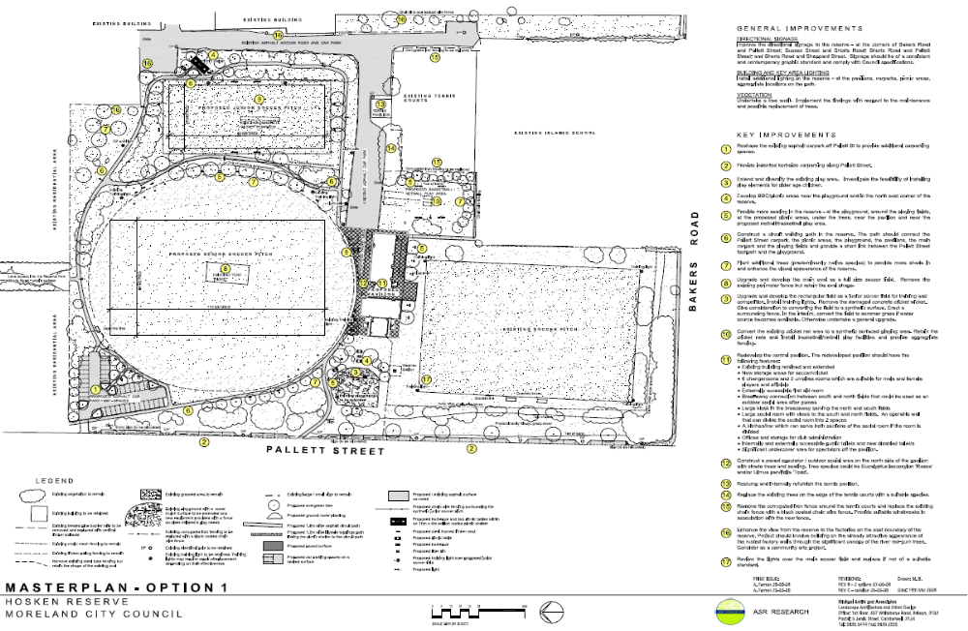
Table 8 – Capital Development Plan Option 1: Hosken Reserve
No | Improvements | Estimated cost  $ | Priority  (Years)
1 | Reshape the existing asphalt carpark off Pallett St to provide additional carparking spaces. | 72000 | 1
2 | Provide indented carparking along Pallett St | 150000 | 1
3 | Extend and diversify the existing play area. Investigate the feasibility of installing play elements for older age children. | 30000 | 1
4 | Develop BBQ/picnic areas near the playground and in the north east corner of the reserve. | 45000 | 2
5 | Provide more seating in the reserve – at the playground, around the playing fields, at the proposed picnic areas, under the trees, near the pavilion and near the proposed netball/basketball play area. | 32000 | 2-5
6 | Construct a circuit walking path in the reserve. The path should connect the Pallett St carpark, the picnic areas, the playground, the pavilions, the main carpark and the playing fields and provide a short link between the Pallett St footpath and the playground. | 90000 | 3
7 | Plant additional trees to provide more shade in and enhance the visual appearance of the reserve. | 11000 | 1
8 | Upgrade and develop the main oval as a full size soccer field. Remove the fence but retain the oval shape. | 60000 | 1
9 | Extend the rectangular field. Remove the damaged concrete cricket wicket and convert the grass surface to synthetic. Install training lights and perimeter fence. | 600000 | 2-3
10 | Convert the cricket net area to a synthetic playing area. Retain the cricket nets and install basketball/netball play facilities and provide appropriate fencing. | 100000 | 2-3
11 | Redevelop the central pavilion. The redeveloped pavilion should have the following features:  - Existing building retained and extended  - New storage areas for soccer/cricket  - 6 changerooms and 2 umpires rooms which are suitable for male and female players and officials  - Externally accessible first aid room  - Breezeway connection between south and north fields that could be used as an outdoor social area after games  - Large kiosk in breezeway serving the north and south fields  - Large social room with views to the south and north fields. An operable wall that can divide the social room into 2 spaces  - A kitchen/bar which can serve both sections of the social room if the room is divided. Offices and storage for club administration  - Internally and externally accessible public toilets and new disabled toilet/s  - Significant undercover area for spectators off the pavilion. | 700000 | 3-5
12 | Construct a paved spectator/outdoor social area on the north side of the pavilion with shade trees and seating. | 80000 | 3-5
13 | Restump and internally refurbish the tennis pavilion. | 20000 | 2
14 | Convert 2 en-tout-cas tennis courts to synthetic. | 80000 | 2
15 | Remove the corrugated iron fence around the tennis courts and replace the existing chain fence with a black coated chain wire fence. | 30000 | 1
16 | Enhance the view from the reserve to the factories on the east boundary of the reserve. Project should involve building on the already attractive appearance of the rusted factory walls through the significant canopy of the river red-gum trees. Consider as a community arts project. | 15000 | 2
17 | Review the lights over the main soccer field and replace if not of a suitable standard. | 40000 | 3
Not shown | Install additional lighting in the reserve – at the pavilions, carparks, picnic areas, appropriate locations on the path. | 36000 | 2
Not shown | Improve the directional signage to the reserve - at the corners of Bakers Rd and Pallett St; Sussex St and Shorts Rd; Shorts Rd and Pallett St; and Shorts Rd and Sheppard St. Signage should be of a consistent and contemporary graphic standard and comply with Council specifications. | 4000 | 1
Not shown | Undertake a tree audit. Implement the findings with respect to the maintenance and possible replacements of trees | 10000 | 2
Plan C – Redevelopment Masterplan Option 2

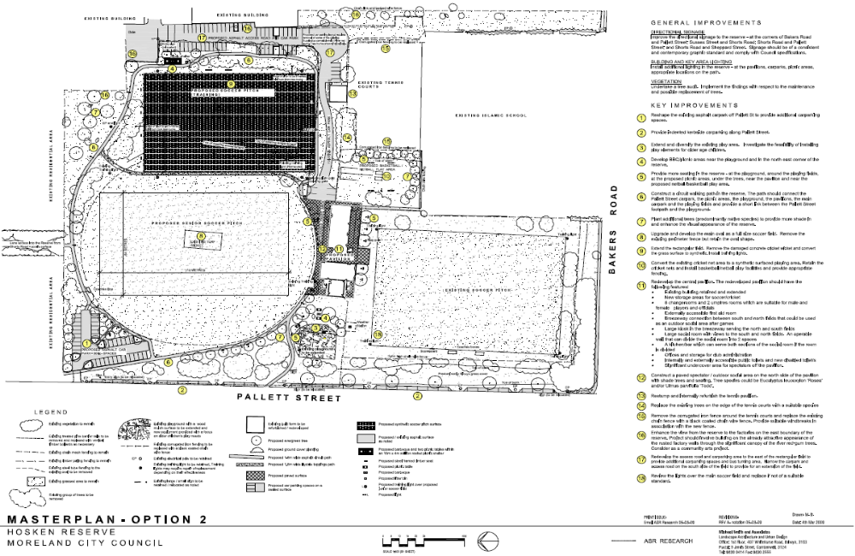
Table 9 – Capital Development Plan Option 2: Hosken Reserve
No | Improvements | Estimated cost  $ | Priority  (Years)
1 | Reshape the existing asphalt carpark off Pallett St to provide additional carparking spaces. | 72000 | 1
2 | Provide indented carparking along Pallett St | 150000 | 1
3 | Extend and diversify the existing play area. Investigate the feasibility of installing play elements for older age children. | 30000 | 1
4 | Develop BBQ/picnic areas near the playground and in the north east corner of the reserve. | 45000 | 2
5 | Provide more seating in the reserve – at the playground, around the playing fields, at the proposed picnic areas, under the trees, near the pavilion and near the proposed netball/basketball play area. | 32000 | 2-5
6 | Construct a circuit walking path in the reserve. The path should connect the Pallett St carpark, the picnic areas, the playground, the pavilions, the main carpark and the playing fields and provide a short link between the Pallett St footpath and the playground. | 90000 | 3
7 | Plant additional trees to provide more shade in and enhance the visual appearance of the reserve. | 11000 | 1
8 | Upgrade and develop the main oval as a full size soccer field. Remove the fence but retain the oval shape. | 60000 | 1
9 | Extend the rectangular field. Remove the damaged concrete cricket wicket and convert the grass surface to synthetic. Install training lights and perimeter fence. | 600000 | 2-3
10 | Convert the cricket net area to a synthetic playing area. Retain the cricket nets and install basketball/netball play facilities and provide appropriate fencing. | 100000 | 2-3
11 | Redevelop the central pavilion. The redeveloped pavilion should have the following features:  - Existing building retained and extended  - New storage areas for soccer/cricket  - 6 changerooms and 2 umpires rooms which are suitable for male and female players and officials  - Externally accessible first aid room  - Breezeway connection between south and north fields that could be used as an outdoor social area after games  - Large kiosk in breezeway serving the north and south fields  - Large social room with views to the south and north fields. An operable wall that can divide the social room into 2 spaces  - A kitchen/bar which can serve both sections of the social room if the room is divided. Offices and storage for club administration  - Internally and externally accessible public toilets and new disabled toilet/s  - Significant undercover area for spectators off the pavilion. | 700000 | 3-5
12 | Construct a paved spectator/outdoor social area on the north side of the pavilion with shade trees and seating. | 80000 | 3-5
13 | Restump and internally refurbish the tennis pavilion. | 20000 | 2
14 | Convert 2 en-tout-cas tennis courts to synthetic. | 80000 | 2
15 | Remove the corrugated iron fence around the tennis courts and replace the existing chain fence with a black coated chain wire fence. | 30000 | 1
16 | Enhance the view from the reserve to the factories on the east boundary of the reserve. Project should involve building on the already attractive appearance of the rusted factory walls through the significant canopy of the river red-gum trees. Consider as a community arts project. | 15000 | 2
17 | Redevelop the access road and carparking area to the east of the rectangular field to provide additional carparking spaces and bus turning area. Narrow the carpark and access road on the south side of the field to provide for an extension of the field. | 150000 | 2-3
18 | Review the lights over the main soccer field and replace if not of a suitable standard. | 40000 | 3
Not shown | Install additional lighting in the reserve – at the pavilions, carparks, picnic areas, appropriate locations on the path. | 36000 | 2
Not shown | Improve the directional signage to the reserve - at the corners of Bakers Rd and Pallett St; Sussex St and Shorts Rd; Shorts Rd and Pallett St; and Shorts Rd and Sheppard St. Signage should be of a consistent and contemporary graphic standard and comply with Council specifications. | 4000 | 1
Not shown | Undertake a tree audit. Implement the findings with respect to the maintenance and possible replacements of trees | 10000 | 2
Plan D – Redevelopment Masterplan Option 3

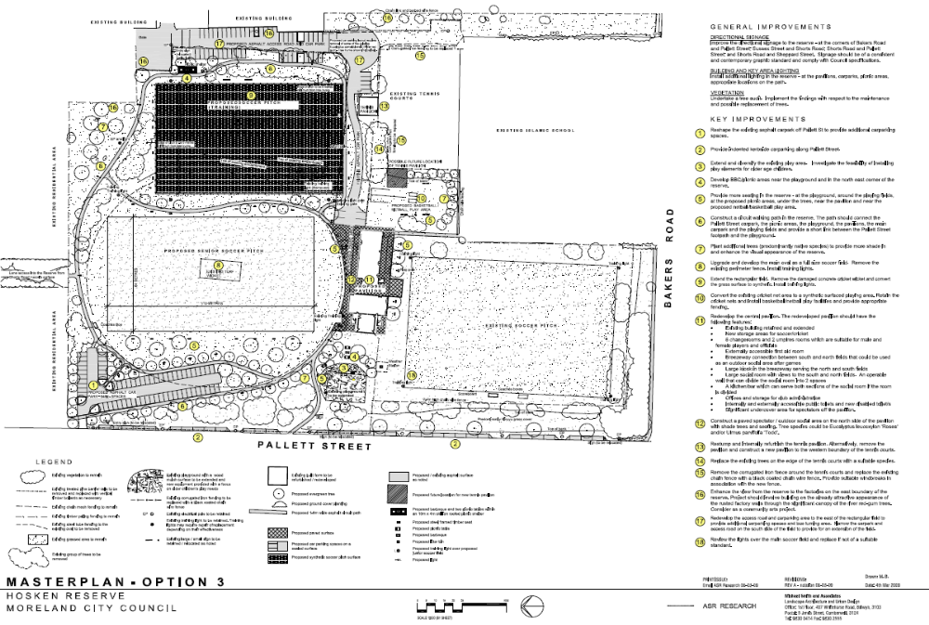
Table 10 – Redevelopment Masterplan Option 3
No | Improvements | Estimated cost  $ | Priority  (Years)
1 | Extend and reshape the existing asphalt carpark off Pallett St to provide additional carparking spaces. | 100000 | 1
2 | Provide indented carparking along Pallett St | 150000 | 1
3 | Extend and diversify the existing play area. Investigate the feasibility of installing play elements for older age children. | 30000 | 1
4 | Develop BBQ/picnic areas near the playground and in the north east corner of the reserve. | 45000 | 2
5 | Provide more seating in the reserve – at the playground, around the playing fields, at the proposed picnic areas, under the trees, near the pavilion and near the proposed netball/basketball play area. | 50000 | 2-5
6 | Construct a circuit walking path in the reserve. The path should connect the Pallett St carpark, the picnic areas, the playground, the pavilions, the main carpark and the playing fields and provide a short link between the Pallett St footpath and the playground. | 90000 | 3
7 | Plant additional trees to provide more shade in and enhance the visual appearance of the reserve. | 15000 | 1
8 | Upgrade and redevelop the main oval as a full size soccer field. Remove the fence. | 60000 | 1
9 | Extend the rectangular field. Remove the damaged concrete cricket wicket and convert the grass surface to synthetic. Install training lights and perimeter fence. | 600000 | 2-3
10 | Convert the cricket net area to a synthetic playing area. Retain the cricket nets and install basketball/netball play facilities and provide appropriate fencing. | 100000 | 2-3
11 | Redevelop the central pavilion. The redeveloped pavilion should have the following features:  - Existing building retained and extended  - New storage areas for soccer/cricket  - 6 changerooms and 2 umpires rooms which are suitable for male and female players and officials  - Externally accessible first aid room  - Breezeway connection between south and north fields that could be used as an outdoor social area after games  - Large kiosk in breezeway serving the north and south fields  - Large social room with views to the south and north fields. An operable wall that can divide the social room into 2 spaces  - A kitchen/bar which can serve both sections of the social room if the room is divided. Offices and storage for club administration  - Internally and externally accessible public toilets and new disabled toilet/s  - Significant undercover area for spectators off the pavilion. | 700000 | 3-5
12 | Construct a paved spectator/outdoor social area on the north side of the pavilion with shade trees and seating. | 80000 | 3-5
13 | Restump and internally refurbish the tennis pavilion. | 20000 | 2
14 | Convert 2 en-tout-cas tennis courts to synthetic. | 80000 | 2
15 | Remove the corrugated iron fence around the tennis courts and replace the existing chain fence with a black coated chain wire fence. | 30000 | 1
16 | Enhance the view from the reserve to the factories on the east boundary of the reserve. Project should involve building on the already attractive appearance of the rusted factory walls through the significant canopy of the river red-gum trees. Consider as a community arts project. | 15000 | 2
17 | Redevelop the access road and carparking area to the east of the rectangular field to provide additional carparking spaces and bus turning area. Narrow the carpark and access road on the south side of the field to provide for an extension of the field. | 150000 | 2-3
18 | Review the lights over the main soccer field and replace if not of a suitable standard. | 40000 | 3
Not shown | Install additional lighting in the reserve – at the pavilions, carparks, picnic areas, appropriate locations on the path. | 36000 | 2
Not shown | Improve the directional signage to the reserve - at the corners of Bakers Rd and Pallett St; Sussex St and Shorts Rd; Shorts Rd and Pallett St; and Shorts Rd and Sheppard St. Signage should be of a consistent and contemporary graphic standard and comply with Council specifications. | 4000 | 1
Not shown | Undertake a tree audit. Implement the findings with respect to the maintenance and possible replacements of trees | 10000 | 2

Concept Options – Redevelopment and Extension of Existing Pavilion
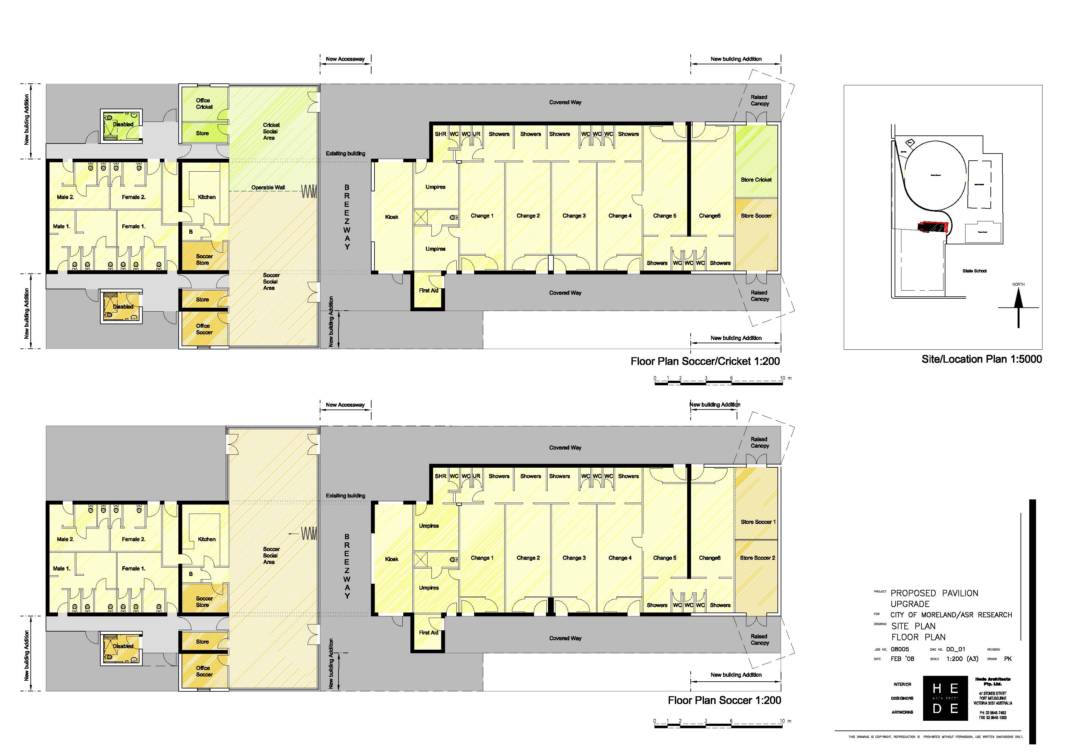

APPENDICES

Appendix A – Residents’ Survey

1. No of respondents

177 households responded to the survey

2. Age ranges

Range – Years | % of respondents
15-19 | 2
20-24 | 2
25-39 | 26
40-59 | 41
60-74 | 14
75+ | 10
Not stated | 4

3. Gender

Male | 47 | Female | 53

4. Length of time living at current address

Range – Years | % of Respondents
0-3 years | 17
4-7years | 14
7-15 years | 21
More than 15 years | 43
Not stated | 5

5. Distance living from Reserve

Distance | % of Respondents
<200m | 27
between 200-500m | 34
between 500-1000m | 21
Other | 8
Not stated | 11

6. Household Structure

Type | % of Respondents
Single person | 22
Sole parent with children living at home | 9
Couple only | 24
Couple with children living at home | 30
Group | 9
Not stated | 6

7. Used the Park in the past 2 years?

Yes | 109 | No | 44 | Not stated | 25

8. Purpose for using the Park and how often?

Activity | How often - daily (D) weekly (W), fortnightly (F) monthly (M), yearly (Y)
 | D  % | W  % | F  % | M  % | Y  %
Soccer | 2 | 5 | 1 | 2 | 2
Tennis | 0 | 2 | 0 | 1 | 6
Australian Rules Football | 2 | 9 | 4 | 3 | 2
Cricket | 2 | 3 | 2 | 2 | 2
Walking for exercise | 20 | 17 | 5 | 6 | 2
Walking the dog | 24 | 11 | 3 | 2 | 2
Running | 6 | 10 | 2 | 5 | 2
Spectating sport | 2 | 7 | 3 | 7 | 2
Using playground | 5 | 16 | 5 | 7 | 4
Enjoying the environment | 10 | 13 | 3 | 1 | 0
Relaxation/contemplation | 12 | 8 | 6 | 3 | 1
As a thoroughfare | 7 | 12 | 3 | 2 | 2

8. Main mode of travel to Park

Mode | % of Respondents
Walk | 83
Car | 8
Bike | 9
Public transport | 0

9. Importance of facilities at the Park

Facility | Very Important | Moderately important | Not very important | Not important at all | Not stated
Soccer fields | 18 | 20 | 10 | 18 | 35
AFL/cricket oval | 26 | 35 | 4 | 10 | 26
Tennis courts | 21 | 20 | 7 | 14 | 38
AFL/cricket pavilion | 22 | 15 | 7 | 14 | 42
Soccer pavilion | 15 | 14 | 12 | 15 | 43
Tennis clubhouse | 18 | 15 | 10 | 15 | 41
Playground | 43 | 15 | 6 | 7 | 29
Trees | 65 | 4 | 0 | 1 | 30
Pathways | 58 | 12 | 2 | 1 | 27
Seats | 48 | 15 | 6 | 1 | 30
Grassed areas for informal play | 56 | 10 | 1 | 2 | 30
Car park | 31 | 11 | 9 | 15 | 35
Public toilets | 35 | 17 | 5 | 6 | 37

10. Standard/quality of the following facilities

Facility | Excellent | Good | Satisfactory | Poor | Not stated
Soccer fields | 6 | 28 | 22 | 1 | 42
AFL / cricket oval | 6 | 21 | 26 | 4 | 43
Tennis courts | 3 | 20 | 23 | 3 | 51
AFL / cricket pavilion | 4 | 15 | 26 | 6 | 49
Soccer pavilion | 1 | 16 | 24 | 4 | 56
Tennis club house | 3 | 10 | 25 | 7 | 55
Playground | 4 | 27 | 24 | 7 | 38
Trees | 7 | 25 | 24 | 16 | 27
Pathways | 7 | 20 | 25 | 19 | 28
Seats | 2 | 12 | 22 | 30 | 34
Grassed areas for informal play | 4 | 19 | 24 | 20 | 33
Car park | 1 | 10 | 25 | 22 | 41
Public toilets | 2 | 12 | 28 | 21 | 37

11. Main reasons for not using the Park (non users)

Reason | % of Respondents
Too busy – other commitments (eg. family, work) | 41
Too far away | 9
Feel unsafe in the Reserve | 17
Not interested in using the Reserve | 9
Do not feel welcome in the Reserve | 13
Do not know what is available in the Reserve | 28
Difficult to get into the Reserve | 9
The facilities I want to use are not provided / accessible | 15
Other | 10

- Improvements to encourage greater use of the Park

Action | % of Respondents
More play equipment | 33
More or better BBQ / picnic facilities | 43
More shelter / shade / seating | 51
Improved surfaces on playing fields | 21
More walking paths | 37
Better signage | 15
Improved safety / security lighting | 7
Improved sports field lighting | 16
Improved access (e.g. entry into fenced areas) | 17
Provision of disability access (e.g. made paths) | 15
Improved / more car parking | 21
Additional planting and landscaping | 44
Provision of public toilet facilities | 41
Improved maintenance generally | 44
13. Other parks used in Coburg Nth Area

The other parks that the respondents visited quite frequently were in popularity order were Bain Reserve, Coburg Lake, Merri Creek and Lake Reserve and Merlynston Park. Their reasons for visiting these parks were to access the playgrounds (e.g. Bain Reserve was considered to have a better playground than Hosken Reserve), enjoy the natural environment, walk and cycle along the baths, walk dogs, have picnics, socialise, rest under the tress in the shade etc

14. Emphasis/priority for redevelopment

Emphasis for redevelopment | Average score
Emphasis on facilities for sport | 3.7
Greater emphasis on facilities for non-sporting activities | 2.6
Greater emphasis on enhancing the natural environment and landscape | 3.0
Greater emphasis on facilities for informal play | 3.6
Greater emphasis on enhancing the visual appearance of the reserve | 3.3
Greater emphasis on the safety of the reserve | 3.7
Note: Respondents were asked to indicate their priority for each item with a score from 1-6, with 1 being a high priority and 6 a low priority. Therefore the lower the average score, the higher the priority or the greater the emphasis.

15. Written comments about problems with or suggested improvements to the Park

Dogs in park

- I don't want to see any less sport played at the reserve, but do find it difficult to make use of the off-leash facilities for dogs on weekends due to organised sport (don't like to take dog off lead in area near the sports field as she could be a menace to kids playing sport)
- It is great that dogs are allowed to be off the leash
- It is a wonderful facility and without it I fear my dogs would not get the exercise and stimulation that they need to be health and well adjusted
- Bring the Dog Club back. There are more than 8 dogs in my street, I believe the dog club would be great for the local community to come together and meet new people and dogs
- Fenced area or well signed area and time say 2 hours daily morning or evening when dogs can run free. I have a bad back and surgically repaired knee which is quite weak and I walk with a limp. I am 59 years old. Follow the home team in season, but physically cannot run with my dog. A few different free areas for the dog to run would be good.
- This oval allows dogs to roam free of leads which is great so it should provide 'doggy poo bags' as should all your reserves
- Dog owners exercising animals need a separate area or alternative venue as 'off leash dogs' approach/harass children/adults using the oval. The park also suffers the usual problem of irresponsible dog owners not 'picking up' after their animals

Droughts and flooding

- There are a number of households in this area who, although they appreciate the severity of the drought actually live in fear of rain because of flooding concerns. The Merlynston Main Drain Redevelopment has a proposed pipeline alignment beside Hosken Reserve. A bike path right around Hosken Reserve is important and a drinking fountain or two, but any re-development must hopefully involve minimising the danger and fear of being flooded out of house and home. Please make flood concerns a priority in re-establishment works
- Condition of reserve is greatly dependent on availability of water
- Whatever you do – do not over develop it. Council should aim to make the reserve water efficient by installing drought resistant trees and plants and an underground water tank. Water could be harvested from nearby runoff including club room rooves, roads and carparks plus school roof.

Litter/Rubbish

- Users need to clean up their rubbish, but there are no rubbish bins. There's always glass, bottles, cans, food scraps, etc on the ground, it is disgusting
- More regular cleaning up of litter.
- Very dirty sometimes when Islamic school is allowed on it during class times, lunch wrappers, etc. Sometimes I have to wait until lunch is over before I can go onto oval.
- Lack of rubbish bins a problem. Get rid of roller that is chained to a light pole - used to smash bottles. At times is a dumping ground for people's rubbish, stolen cars, etc
- The car park at the north east corner of the Australian International Academyhas a constant litter problem particularly beer and drink bottles and other dumped rubbish and this is not helped by a lack of street lighting. The same comments apply to the car park outside the tennis courts
- The tree zone on Hosken Reserve at the corner of Pallett Street and Bakers Rd is rarely cleared of litter and dead tree branches by Council. It requires immediate attention and periodic maintenance
- I find some areas are particularly dirty i.e. strewn with rubbish particularly the entry from Shorts Rd and the carpark area is often littered with broken glass.
- Litter/glass is a big problem, especially after football games
- Mess often found after local school uses it at lunch time. Good for school to use it, but should clean up afterwards. Dog walking is important
- Need bins at the park area, near tables on edge of oval and carpark end, there is always empty drinks and rubbish from people in their cars, the one bin that is there is always full and no bags in bag holder for dog poo.
- Poor maintenance by group users. Rubbish littered around reserve. Worse during the school term and post sporting events. King Khalid school, Nth Coburg Saints, Haig Cricket Club and the soccer club need to combine with the Council more to keep this valued public area clean. Also Council staff need to pick up litter instead of just mowing over it and spreading the mess further
- I am always concerned about the amount of broken glass around the football field
- The reserve is in desperate need of rubbish bins
Lighting

- Lighting during winter months is needed for safety of walkers (X4)
- There needs to be better lighting of the carpark on Pallett St to discourage people in cars just sitting

Passive/informal play spaces/paths

- I feel there needs to be a balance between active and passive sports e.g. there could be 10xfitness stations placed around the park, distances for laps of the park could be written on a board in this/other parks to encourage people to keep a track of kms etc. Better access through to Bakers Rd for people who walk to the tram. Also there is no netball/basketball wall such as that at Coles Reserve. As long as it met regulations, I feel this would be a great addition or even a small flexi-turf count (1/2) would be good (or full if a budget allowed for this)
- School and Community Partnerships eg. the facility at Reservoir Sec. College is excellent as is the one at Broadmeadows Leisure Centre (4 x full basketball/netball courts). So even one outdoor flexi/asphalt court at the park may be well used
- A cycling path should be constructed through Hosken Reserve linking Shorts Road to Ulm Street and/or the Sanger Reserve Path. Sport is important but also passive recreation too. Environment aspects, eg trees and safe lighting for after dark walking.
- The broken footpaths must be repaired
- The old trees should be checked for dangerous branches
- I believe with greater public awareness of reserve and introducing events, picnic area, more playground equipment and a safety fence along road more people would use the reserve. Often people don't know it is here because it is on the rise when driving
- Provide BBQ facilities and self cleaning toilet
- The Reserve is so convenient because we do not need car/petrol/extra time for carparking, etc. to get there. Because of walking distance and with other neighbours, it can be a meeting up spot. Since in today's society many neighbours are unfriendly, this socialization will be lost if reserve is changed dramatically.
- A man made lake. A safe playground area somewhere where children could play in a safe environment. More playground equipment, more trees/plants. Screen the eyesore factories on Eastern side. Looks really ugly
- Kids play area needs a shade cloth. Often too hot to bring kids there. Also no bins
- The area from the Shorts Rd entry around the oval to the carpark is very uneven making walking hard at times and it seems to get very muddy after a lot of rain which is strange as it is slightly sloped
- I have been using this Reserve since I was 4 years old so it is now 40 years. In that time I have hardly seen it change. I am hoping it gets the facelift it deserves. The reserve should not just be for group sporting events e.g. football
- The birds are very thirsty with this drought. Could you consider bird baths/fountains for our poor thirsty birds?
- Hosken Reserve is located between industrial properties and Merlynston homes and a school. Workers, residents and school children all have a right to use it for all the activities listed on the questionnaire. My concern is that because the industrial area is ugly and abandoned in areas, that the park will reflect this. Perhaps the whole area south of the school needs discussion about its future direction. Empty, abandoned factories and there is a housing crisis
- The playground for children needs sun protection i.e. shade cloth coverings, especially over swings and fort. On hot days it cannot be used. Fencing around would make it safer for parents to relax and enjoy surroundings or use oval for fitness. More seating would be nice too
- It really does need an overhaul. It has been the same for over 40 years. The playground needs to have some much better equipment. The emphasis should not just be for group sporting events

Sports facilities

- We are fortunate to have many parks in the area that are great playgrounds but, I think it is also vital that the community supports the local sports and sport groups. I know that Hosken Reserve has a long history as a sports ground and indeed it is timeless just to sit for a while under the trees and watch some cricket or footie at the grass roots
- Nice to have regular sports to spectate especially cricket and Australian Rules
- Soccer ground is locked except when used for matches. Should be available for use when matches not scheduled e.g. fenced area to walk dogs.
- Our children currently play soccer and tennis at the Reserve. Unfortunately the facilities at both clubs are old and tired and although both groups do their utmost to fundraise and enhance the infrastructure. A lot more needs to be done and this can only be accomplished by Council's support. The Reserve is used daily by many families and is the heart of our community.
- Hosken Reserve has been an asset to our family over the many years playing cricket, football, tennis and using the other facilities.
- Maybe an area set aside for bocce or bowls
- While the football and soccer playing surfaces are about the best in the area, the tennis court surfaces are pathetic and have been for over 20 years now. Council needs to dig them up and replace them with a mod-grass surface. It is less damaged in weather, can drain water better providing year round enjoyment and competition and requires less maintenance and costs to maintain.
- People/children using oval tend to be peaceful citizens. It was the main outlet when we came here from NW Aust in 1957 before we obtained a car - with 5 children. We have all either played cricket, football and some tennis - all used it extensively for walking exercise and as sports spectators in early years. Now alone, I still value it.
- I love the fact that it is a hive of activity on weekends and week nights (training for soccer/footy, etc). It promotes an active, outdoors community. Parking must be improved.
- We need to provide grounds where sports can be played safely. We need to look at drought proofing them or at other surfaces. We also need to provide better club houses and seating facilities for spectators.
- Could probably enhance surface of the area west of oval. Either repair or remove concrete pitch.
- I think it would be great if the tennis club was overhauled improving the attendance and surface etc. Also provision for basketball would be very good
- This Reserve should have all sporting teams playing there. The Reserve is for all to use. The size of this Reserve should accommodate everybody. Because of this becoming a young area, we should accommodate all sports so it will help to keep the youth off the streets and give them an interest in the area they live in

Behaviour in Park

- I used to walk my dog regularly at 5.30 am in Hosken Reserve but too frequently met up with unsavoury types - playing loud music, doing burn-outs in car park, etc. I have also reported 3 stolen/burnt out cars to police, break-ins at the canteen of footy club - dreadful graffitti on the Tennis Club walls and found remnants of bongs almost every weekend.
- At night cars are frequently, almost every night, parked in the 2 car parks - outside tennis courts and north-east corner of the Australian International Academy(both in darkness). Occupants of cars are often drinking, abusive and intimidating by their behaviour. This deters residents from strolling around the reserve in the evenings. The same situation existed at the Pallett Street car park until Council installed chains to prevent vehicle access. If Council proposes to remove the chains on the Pallett St car park, then Council can expect complaints from residents. Vehicle access creates serious problems for residents including loutish behaviour, car revving and burn-outs in the car parks
- I would appreciate security cameras installed and their existence be known to people using the Hosken Reserve to deter any problems by users to make it safe for all
- I hope you do something with the hoons doing burnouts and loud music at 2.00am

Traffic/signage/carparking

- The car park off Pallett Street needs complete makeover
- 10km speed limit signs from Sheppard St. into Reserve as speeding motorists endanger people walking on road. Signage on Shorts Rd., Sheppard St. corner advising 'no through road'
- Traffic management needs to improve i.e. large number of cars driving to school to drop off children
- On Saturday's, cars are everywhere. Car parking is a nightmare. While I walk there, quite often the cars make it look like a junkyard
- I am concerned that greater emphasis on sport will mean more traffic in the area especially more cars parking in Kingsford Ave in front of our house! Also, if more sport is played at night the bright lights and noise will make it a less peaceful environment
- Parking in the reserve need a major upgrade also
- Fix the problem of the carpark at Pallett Street. When it is not chained up, too many hoons and rubbish is being dumped. Dirty - condoms, dirty underwear, clothes after weekend of blokey sports - not good for children
- Illegal parking of cars on Hosken Reserve in Pallett Street between Bakers Rd and Ulm St is a constant problem during business hours and more trees should be planted along this strip

Appearance of reserve

- It looks rundown - especially the areas surrounding the football (AFL) oval - the old pavilion was pulled down and replaced by a makeshift car park
- It is hard to cross Bakers Road sometimes due to speeding traffic. Walking access especially with the pram is difficult at Bakers Rd and Pallett St because there is no footpath on Pallet St and you have to almost walk on the road at this very dangerous intersection where collisions are frequent. If there was more concentration on aesthetics, trees, landscaping, walking tracks, etc and less emphasis on sporting grounds, I would find the reserve a far more appealing place to use
- Would love to see reserve become more user friendly for children of all ages and also inviting to many older good quality persons. Currently the Reserve is not appealing enough to take my young kids to play there, which is a real shame
- We need more parks and nature facilities at the Reserve to counter the light industrial pollution producing estate nearby in Bakers Rd etc. The more forest the more healthy the environment
- Mess often found after local school uses it at lunch time. Good for school to use it, but should clean up afterwards. Dog walking is important
- Create indented parking in Pallet Street as on match days it is difficult to drive in the street with the large volume of cars that park there
- Need bins at the park area, near tables on edge of oval and carpark end, there is always empty drinks and rubbish from people in their cars, the one bin that is there is always full and no bags in bag holder for dog poo
- Poor maintenance by group users. Rubbish littered around reserve. Worse during the school term and post sporting events. King Khalid school, Nth Coburg Saints, Haig Cricket Club and the soccer club need to combine with the Council more to keep this valued public area clean. Also Council staff need to pick up litter instead of just mowing over it and spreading the mess further
- The Council and Yarra Valley Water have done a great job maintaining the playing surface of the main oval given the drought. With regard to future use of the reserve, it suffers like so much of the suburb from lack of trees and shady spots. I would encourage as much tree planting and grass space for relaxed family time
- I am always concerned about the amount of broken glass around the football field. The shaded areas are not utilised as there is no seating, BBQs or paths to encourage their use.

